**Domestic Tour & Travel**

**A PROJECT REPORT**

*In partial fulfilment of the requirements for the award of the degree*

**BACHELOR OF COMPUTER APPLICATION**

***Under the guidance of***

**Lakhan Mahato**

**BY**

**Abhranil Kundu**

**Dipayan Sarkar**



**The Heritage Academy**

*In association with*



***(ISO9001:2015)***

*SDF Building, Module #132, Ground Floor, Salt Lake City, GP Block, Sector V, Kolkata, West Bengal 700091*

***(Note: All entries of the proforma of approval should be filled up with appropriate and complete information. Incomplete proforma of approval in any respect will be summarily rejected.)***

**Title of the Project: Domestic Tour & Travel**

**Project Members: Abhranil Kundu**

**Dipayan Sarkar**

**Name of the guide: Lakhan Mahato**

**Address:** **Ardent Computech Pvt. Ltd (An ISO 9001:2015 Certified)**

***SDF Building, Module #132, Ground Floor, Salt Lake City, GP Block, Sector V, Kolkata, West Bengal, 700091.***

**Project Version Control History:**

|  |  |  |  |
| --- | --- | --- | --- |
| **Version** | **Primary Author** | **Description of Version** | **Date Completed** |
| **Final** | **Abhranil Kundu**  **Dipayan Sarkar** | **Project Report** |  |

**Signature of Approver**

**Date:**

**Signature of Team Members**

**Date:**

**DECLARATION**

We hereby declare that the project work being presented in the project proposal entitled “**Domestic Tour &Travel**” in partial fulfilment of the requirements for the award of the degree of **BACHELOR OF COMPUTER APPLICATION at ARDENT COMPUTECH PVT. LTD, SALTLAKE, KOLKATA, WEST BENGAL**, is an authentic work carried out under the guidance of **Mr. Lakhan Mahato**. The matter embodied in this project work has not been submitted elsewhere for the award of any degree of our knowledge and belief.

**Signature of the students:**



**Ardent Computech Pvt. Ltd (An ISO 9001:2015 Certified)**

SDF Building, Module #132, Ground Floor, Salt Lake City, GP Block, Sector V, Kolkata, West Bengal 700091

**CERTIFICATE**

This is to certify that this proposal of minor project entitled “**Domestic Tour & Travel**” is a record of bonafide work, carried out by **Abhranil Kundu & Dipayan Sarkar** under my guidance at **ARDENT COMPUTECH PVT LTD**. In my opinion, the report in its present form is in partial fulfilment of the requirements for the award of the degree of **BACHELOR OF COMPUTER APPLICATION** and as per regulations of the **ARDENT®.** To the best of my knowledge, the results embodied in this report, are original in nature and worthy of incorporation in the present version of the report.

**Guide / Supervisor**

**MR. Lakhan Mahato**

**Ardent Computech Pvt. Ltd (An ISO 9001:2015 Certified)**

SDF Building, Module #132, Ground Floor, Salt Lake City, GP Block, Sector V, Kolkata, West Bengal 700091

**ACKNOWLEDGEMENT**

Success of any project depends largely on the encouragement and guidelines of many others. I take this sincere opportunity to express my gratitude to the people who have been instrumental in the successful completion of this project work.

I would like to show our greatest appreciation to **Mr. Lakhan Mahato**, Project Engineer at Ardent, Kolkata. I always feel motivated and encouraged every time by his valuable advice and constant inspiration; without his encouragement and guidance this project would not have materialized.

Words are inadequate in offering our thanks to the other trainees, project assistants and other members at Ardent Computech Pvt. Ltd. for their encouragement and cooperation in carrying out this project work. The guidance and support received from all the members and who are contributing to this project, was vital for the success of this project.

**Contents**

Domestic Tour & Travel

|  |  |  |
| --- | --- | --- |
| SL. NO | NAME | PAGE |
| 1 | **Abstract** | 7 |
| 2 | **Introduction** | 8 |
| 3 | **Project Category** | 9 |
| 4 | **Hardware and Software Requirements** | 10 |
| 5 | **SDLC Process Applied** | 11 |
| 6 | **ER Diagram** | 17 |
| 7 | **Non-functional Requirements** | 19 |
| 8 | **Project Planning** | 21 |
| 9 | **Software Engineering Paradigm applied** | 22 |
| 10 | **Database Design** | 23 |
| 11 | **User Interface Design** | 26 |
| 12 | **Source Code** | 42 |
| 13 | **Testing** | 43 |
| 14 | **Cost Estimation of the Project along with Cost Estimation Model** | 47 |
| 15 | **Future scope and further enhancement of the Project** | 48 |
| 16 | **Conclusion and Bibliography** | 49 |

**Abstract**

Domestic tour and travel play a vital role in the booming tourism industry, attracting a growing number of individuals seeking unique experiences within their own country. As people become increasingly interested in events and willing to travel to participate in them, destinations must strategically plan and develop their offerings to fully harness the tourism potential of events. However, there is a lack of studies on how tour strategies are actually implemented in destinations. To address this gap, our study focuses on tour and travel management systems, aiming to explore tour and travel packages. We provide comprehensive services, including ticket bookings, hotel reservations, rental car services, and holiday tour packages. Our goal is to offer customers the most suitable and customized travel packages, ensuring all their needs are met conveniently under one roof. With our expertise and commitment, we aim to enhance the domestic tourism experience and contribute to the growth of the tourism industry.

**Introduction**

Welcome to our domestic tour and travel website, your one-stop destination for discovering and planning unforgettable journeys within your own country. We understand the growing desire to explore the beauty and diversity of local destinations, and our website is designed to cater to your every travel need.

We believe that domestic travel offers a wealth of incredible experiences waiting to be discovered. Our user-friendly website provides a seamless platform where you can browse through a wide range of tour options, explore captivating destinations, and find the perfect itinerary to suit your preferences.

With our comprehensive services, you can effortlessly book tickets, secure accommodations, arrange reliable transportation, and even select from a variety of enticing holiday packages. Our website showcases the most exciting attractions, hidden gems, and cultural highlights that your country has to offer, empowering you to plan your dream vacation with ease.

We take pride in providing exceptional customer service, ensuring that your journey is smooth and stress-free from start to finish. Our website is constantly updated with the latest travel information, insider tips, and special offers to enhance your travel experience.

Discover the wonders of your own country and embark on an extraordinary domestic adventure through our convenient and user-friendly website. Start planning your next unforgettable journey today.

**Project Category**

**Web Application:**

A web application is a computer program that utilizes web browsers and web technology to perform tasks over the Internet.

**Overview :**

Millions of businesses use the Internet as a cost-effective communications channel. It lets them exchange information with their target market and make fast, secure transactions. However, effective engagement is only possible when the business is able to capture and store all the necessary data, and have a means of processing this information and presenting the results to the user.

Web applications use a combination of server-side scripts (PHP and ASP) to handle the storage and retrieval of the information, and clientside scripts (JavaScript and HTML) to present information to users. This allows users to interact with the company using online forms, content management systems, shopping carts and more. In addition, the applications allow employees to create documents, share information, collaborate on projects, and work on common documents regardless of location or device.

**HOW A WEB APPLICATION WORKS:**

Web applications are usually coded in browser-supported language such as JavaScript and HTML as these languages rely on the browser to render the program executable. Some of the applications are dynamic, requiring server-side processing. Others are completely static with no processing required at the server.

**Hardware and Software Requirements**

**Hardware Requirements:** C.P.U. 2.0GHz, RAM-2GB, Hard Drive- 50GB.

**Software Requirements:** Xampp, VS Code, Sublime Text.

**Browser Requirements:** Chrome or Any Browser

**SDLC Process Applied**

The systems development life cycle (SDLC), also referred to as the application development life-cycle, is a term used in systems engineering, information systems and software engineering to describe a process for planning, creating, testing, and deploying an information system. The systems development lifecycle concept applies to a range of hardware and software configurations, as a system can be composed of hardware only, software only, or a combination of both. There are usually six stages in this cycle: analysis, design, development and testing, implementation, documentation, and evaluation.

**Overview**

A systems development life cycle is composed of a number of clearly defined and distinct work phases which are used by systems engineers and systems developers to plan for, design, build, test, and deliver information systems. Like anything that is manufactured on an assembly line, an SDLC aims to produce high-quality systems that meet or exceed customer expectations, based on customer requirements, by delivering systems which move through each clearly defined phase, within scheduled time frames and cost estimates. Computer systems are complex and often (especially with the recent rise of service-oriented architecture) link multiple traditional systems potentially supplied by different software vendors. To manage this level of complexity, a number of SDLC models or methodologies have been created, such as waterfall, spiral, Agile software development, rapid prototyping, incremental, and synchronize and stabilize.

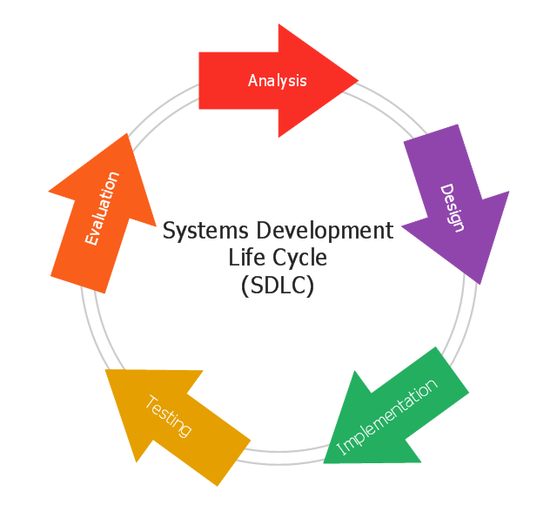

**History and details**

The product life cycle describes the process for building information systems in a very deliberate, structured and methodical way, reiterating each stage of the product's life. The systems development life cycle, according to Elliott & Strachan & Radford (2004), "originated in the 1960s, to develop large scale functional business systems in an age of large-scale business conglomerates. Information systems activities revolved around heavy data processing and number crunching routines".

Several systems development frameworks have been partly based on SDLC, such as the structured systems analysis and design method (SSADM) produced for the UK government Office of Government Commerce in the 1980s. Ever since, according to Elliott (2004), "the traditional life cycle approaches to systems development have been increasingly replaced with alternative approaches and frameworks, which attempted to overcome some of the inherent deficiencies of the traditional SDLC".

**Phases**

The system development life cycle framework provides a sequence of activities for system designers and developers to follow. It consists of a set of steps or phases in which each phase of the SDLC uses the results of the previous one.

The SDLC adheres to important phases that are essential for developers—such as planning, analysis, design, and implementation— and are explained in the section below. This includes evaluation of the currently used system, information gathering, feasibility studies, and request approval. A number of SDLC models have been created, including waterfall, fountain, spiral, build and fix, rapid prototyping, incremental, synchronize, and stabilize. The oldest of these, and the best known, is the waterfall model, a sequence of stages in which the output of each stage becomes the input for the next. These stages can be characterized and divided up in different ways, including the following:

A ten-phase version of the systems development life cycle

**Preliminary analysis:** Begin with a preliminary analysis, propose alternative solutions, describe costs and benefits, and submit a preliminary plan with recommendations.

**Conduct the preliminary analysis:** Discover the organization's objectives and the nature and scope of the problem under study. Even if a problem refers only to a small segment of the organization itself, find out what the objectives of the organization itself are. Then see how the problem being studied fits in with them.

**Propose alternative solutions:** After digging into the organization's objectives and specific problems, several solutions may have been discovered. However, alternate proposals may still come from interviewing employees,

clients, suppliers, and/or consultants. Insight may also be gained by researching what competitors are doing.

**Cost benefit analysis:** Analyse and describe the costs and benefits of implementing the proposed changes. In the end, the ultimate decision on whether to leave the system as is, improve it, or develop a new system will be guided by this and the rest of the preliminary analysis data.

Systems analysis, requirements definition: Define project goals into defined functions and operations of the intended application. This involves the process of gathering and interpreting facts, diagnosing problems, and recommending improvements to the system. Project goals will be further aided by analysis of end-user information needs and the removal of any inconsistencies and incompleteness in these requirements.

**A series of steps followed by the developer include:**

**Collection of facts:** Obtain end user requirements through documentation, client interviews, observation, and questionnaires.

**Scrutiny of the existing system:** Identify pros and cons of the current system in- place, so as to carry forward the pros and avoid the cons in the new system.

**Analysis of the proposed system:** Find solutions to the shortcomings described in step two and prepare the specifications using any specific user proposals.

**Systems design:** At this step desired features and operations are described in detail, including screen layouts, business rules, process diagrams, pseudo code, and other documentation.

**Development:** The real code is written here.

**Integration and testing:** All the pieces are brought together into a special testing environment, then checked for errors, bugs, and interoperability.

**Acceptance, installation, deployment:** This is the final stage of initial development, where the software is put into production and runs actual business.

**Maintenance:** During the maintenance stage of the SDLC, the system is assessed/evaluated to ensure it does not become obsolete. This is also where changes are made to initial software.

**Evaluation:** Some companies do not view this as an official stage of the SDLC, while others consider it to be an extension of the maintenance stage, and may be referred to in some circles as post-implementation review. This is where the system that was developed, as well as the entire process, is evaluated. Some of the questions that need to be answered include if the newly implemented system meets the initial business requirements and objectives, if the system is reliable and fault-tolerant, and if it functions according to the approved functional requirements. In addition to evaluating the software that was released, it is important to assess the effectiveness of the development process. If there are any aspects of the entire process (or certain stages) that management is not satisfied with, this is the time to improve.

**Disposal:** In this phase, plans are developed for discontinuing the use of system information, hardware, and software and making the transition to a new system. The purpose here is to properly move, archive, discard, or destroy information, hardware, and software that is being replaced, in a manner that prevents any possibility of unauthorized disclosure of sensitive data. The disposal activities ensure proper migration to a new system. Particular emphasises given to proper preservation and archiving of data processed by the previous system. All of this should be done in accordance with the organization's security requirements.[14]

In the following diagram, these stages of the systems development life cycle are divided in ten steps, from definition to creation and modification of IT work products. Not every project will require that the phases be sequentially executed. However, the phases are interdependent. Depending upon the size and complexity of the project, phases may be combined or may overlap.

**System investigation**

First the IT system proposal is investigated. During this step, consider all current priorities that would be affected and how they should be handled. Before any system planning is done, a feasibility study should be conducted to determine if creating a new or improved system is a viable solution. This will help to determine the costs, benefits, resource requirements, and specific user needs required for completion. The development process can only continue once management approves of the recommendations from the feasibility study.

The following represent different components of the feasibility study:

* Operational feasibility
* Economic feasibility
* Technical feasibility
* Human factors feasibility
* Legal/Political feasibility

**Analysis**

The goal of analysis is to determine where the problem is, in an attempt to fix the system. This step involves breaking down the system in different pieces to analyse the situation, analysing project goals, breaking down what needs to be created, and attempting to engage users so that definite requirements can be defined.

**Design**

In systems design, the design functions and operations are described in detail, including screen layouts, business rules, process diagrams, and other documentation. The output of this stage will describe the new system as a collection of modules or subsystems.

The design stage takes as its initial input the requirements identified in the approved requirements document. For each requirement, a set of one or more design elements will be produced as a result of interviews, workshops, and/or prototype efforts.

Design elements describe the desired system features in detail, and they generally include functional hierarchy diagrams, screen layout diagrams, tables of business rules, business process diagrams, pseudo-code, and a complete entity-relationship diagram with a full data dictionary. These design elements are intended to describe the system in sufficient detail, such that skilled developers and engineers may develop and deliver the system with minimal additional input design.

**Testing**

The code is tested at various levels in software testing. Unit, system, and user acceptance testing’s are often performed. This is a grey area as many different opinions exist as to what the stages of testing are and how much, if any iteration occurs. Iteration is not generally part of the waterfall model, but the means to rectify defects and validate fixes prior to deployment is incorporated into this phase.

**ER Diagram**

**What is the ER Model?**

The ER or (Entity Relational Model) is a high-level conceptual data model diagram. Entity-Relation model is based on the notion of real-world entities and the relationship between them.

**Why use ER Diagrams?**

Here, are prime reasons for using the ER Diagram

• Helps you to define terms related to entity relationship modelling

• Provide a preview of how all your tables should connect, what fields are going to be on each table

• Helps to describe entities, attributes, relationships

• ER diagrams are translatable into relational tables which allows you to build databases quickly

• ER diagrams can be used by database designers as a blueprint for implementing data in specific software applications

• The database designer gains a better understanding of the information to be contained in the database with the help of ERP diagram

• ERD is allowed you to communicate with the logical structure of the database to users.

**Components of the ER Diagram**

This model is based on three basic concepts:

• Entities

• Attributes

• Relationships

**ER Diagram**

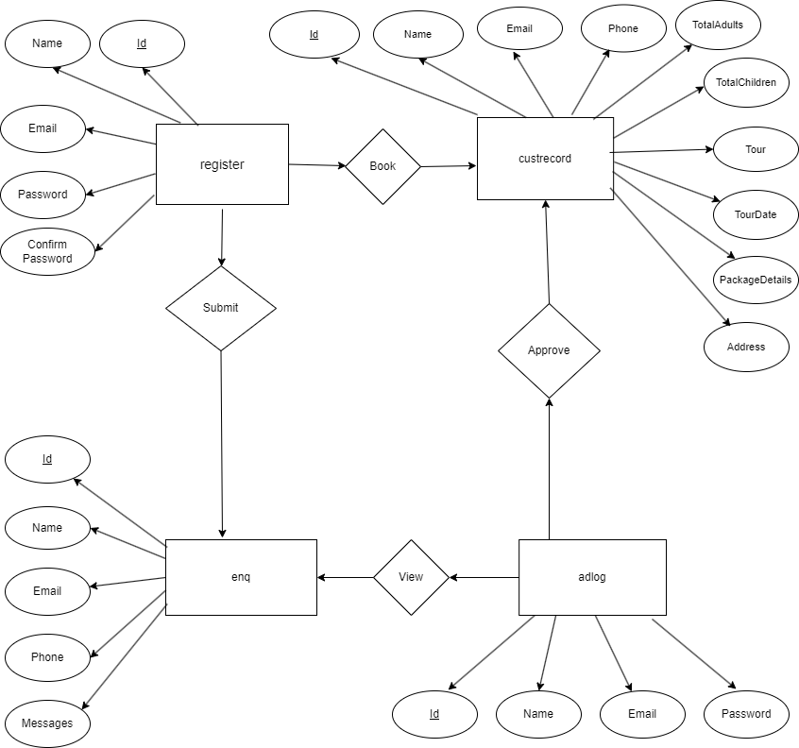

**Use Case Diagram**

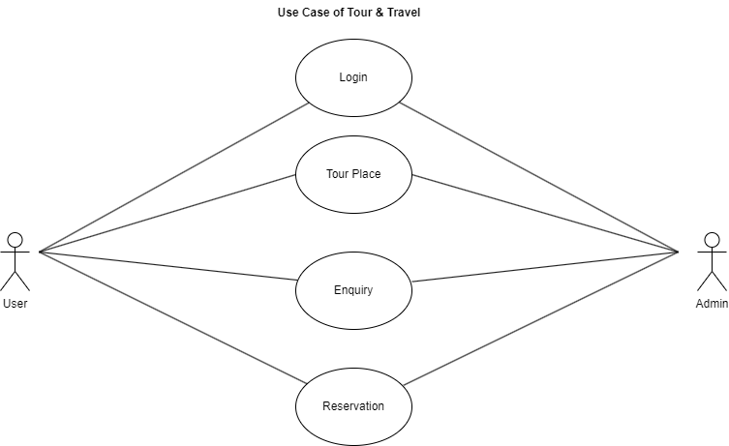

**Non-functional Requirements**

In addition to the obvious features and functions that you will provide in your system, there are other requirements that don't actually DO anything, but are important characteristics nevertheless. These are called "non-functional requirements" or sometimes "Quality Attributes." For example, attributes such as performance, security, usability, compatibility. aren't a "feature" of the system, but are a required characteristic. You can't write a specific line of code to implement them; rather they are "emergent" properties that arise from the entire solution. The specification needs to describe any such attributes the customer requires. You must decide the kind of requirements that apply to your project and include those that are appropriate.

Each requirement is simply stated in english. Each requirement must be objective and quantifiable; there must be some measurable way to assess whether the requirement has been met.

Often deciding on quality attributes requires making tradeoffs, e.g., between performance and maintainability. In the APPENDIX you must include an engineering analysis of any significant decisions regarding tradeoffs between competing attributes.

Here are some examples of non-functional requirements:

**Performance requirements**

Requirements about resources required, response time, transaction rates, throughput, benchmark specifications or anything else having to do with performance.

For better performance the application will restrict the document size to 5 MB.

**Operating constraints**

List any run-time constraints. This could include system resources, people, needed software, The application must run without any manual intervention.

**Platform constraints**

Discuss the target platform. Be as specific or general as the user requires. If the user doesn't care, there are still platform constraints.

Since the application will be developed in php it is platform independent.

**Accuracy and Precision**

Requirements about the accuracy and precision of the data. (Do you know the difference?) Beware of 100% requirements; they often cost too much.

**Modifiability**

Requirements about the effort required to make changes in the software. Often, the measurement is personnel effort (person- months).

**Portability**

The effort required to move the software to a different target platform. The measurement is most commonly person-months or % of modules that need changing.

**Minimal Reliability**

Requirements about how often the software fails. The measurement is often expressed in MTBF (mean time between failures). The definition of a failure must be clear. Also, don't confuse reliability with availability which is quite a different kind of requirement. Be sure to specify the consequences of software failure, how to protect from failure, a strategy for error detection, and a strategy for correction.

**Security**

One or more requirements about protection of your system and its data. The measurement can be expressed in a variety of ways (effort, skill level, time, ...) to break into the system. Do not discuss solutions (e.g. passwords) in a requirements document. Only secured users can access the application. No one can go to any independent page without logging in.

**Usability**

Requirements about how difficult it will be to learn and operate the system. The requirements are often expressed in learning time or similar metrics.

**Project Planning**

Project planning is concerned with identifying the following for every project:

• Activities

• Milestones

• Deliverables.

A plan must be drawn up to guide the development towards the project goal. A plan is drawn up at the start of a project. This plan should be used as the driver for the project. The initial plan is not static, and must be modified as the project progresses.

Planning is required for development activities from specification through to delivery of the system.

**GANTT CHART**

|  |  |  |  |  |  |
| --- | --- | --- | --- | --- | --- |
| **Task** | **Person(s) Responsible** | **Week 1** | **Week 2** | **Week 3** | **Week 4** |
| **Communication** |  |  |  |  |  |
| **Quick Plan** |  |  |  |  |  |
| **Modelling Quick Design** |  |  |  |  |  |
| **Construction of Prototype** |  |  |  |  |  |
| **Deployment, Delivery and Feedback** |  |  |  |  |  |

**Software Engineering Paradigm applied**

**What is a data flow diagram (DFD)?**

A picture is worth a thousand words. A Data Flow Diagram (DFD) is traditional visual representation of the information flows within a system. A neat and clear DFD can depict a good amount of the system requirements graphically. It can be manual, automated, or combination of both.

It shows how information enters and leaves the system, what changes the information and where information is stored. The purpose of a DFD is to show the scope and boundaries of a system as a whole. It may be used as a communications tool between a systems analyst and any person who plays a part in the system that acts as the starting point for redesigning a system.

**Level 0**

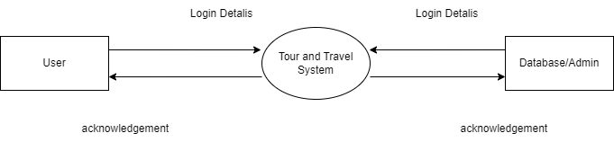

**Level 1**

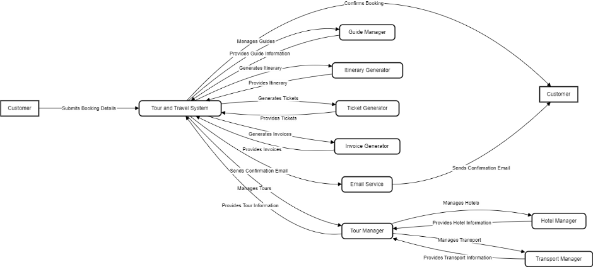

**Database Design**

**What is Database?**

A database is an organized collection of data, generally stored and accessed electronically from a computer system. Where databases are more complex they are often developed using formal design and modelling techniques.

The database management system (DBMS) is the software that interacts with end users, applications, and the database itself to capture and analyze the data. The DBMS software additionally encompasses the core facilities provided to administer the database.

The sum total of the database, the DBMS and the associated applications can be referred to as a "database system". Often the term "database" is also used to loosely refer to any of the DBMS, the database system or an application associated with the database.

Computer scientists may classify database-management systems according to the database models that they support. Relational databases became dominant in the 1980s. These model data as rows and columns in a series of tables, and the vast majority use SQL for writing and querying data. In the 2000s, non-relational databases became popular, referred to as NoSQL because they use different query languages.

**MySQL**

MySQL is an Oracle-backed open source relational database management system (RDBMS) based on Structured Query Language (SQL). MySQL runs on virtually all platforms, including Linux, UNIX and Windows. Although it can be used in a wide range of applications, MySQL is most often associated with web applications and online publishing.

MySQL is an important component of an open source enterprise stack called LAMP. LAMP is a web development platform that uses Linux as the operating system, Apache as the web server, MySQL as the relational database management system and PHP as the object-oriented scripting language. (Sometimes Perl or Python is used instead of PHP.)

Originally conceived by the Swedish company MySQL AB, MySQL was acquired by Sun Microsystems in 2008 and then by Oracle when it bought Sun in 2010.

Developers can use MySQL under the GNU General Public License (GPL), but enterprises must obtain a commercial license from Oracle.

Today, MySQL is the RDBMS behind many of the top websites in the world and countless corporate and consumer-facing web-based applications, including Facebook, Twitter and YouTube.

**How MySQL works**

MySQL is based on a client-server model. The core of MySQL is MySQL server, which handles all of the database instructions (or commands). MySQL server is available as a separate program for use in a client-server networked environment and as a library that can be embedded (or linked) into seperate applications.

MySQL operates along with several utility programs which support the administration of MySQL databases. Commands are sent to MySQLServer via the MySQL client, which is installed on a computer.

MySQL was originally developed to handle large databases quickly. Although MySQL is typically installed on only one machine, it is able to send the database to multiple locations, as users are able to access it via different MySQL client interfaces. These interfaces send SQL statements to the server and then display the results.

**Login/Sign Up Database**

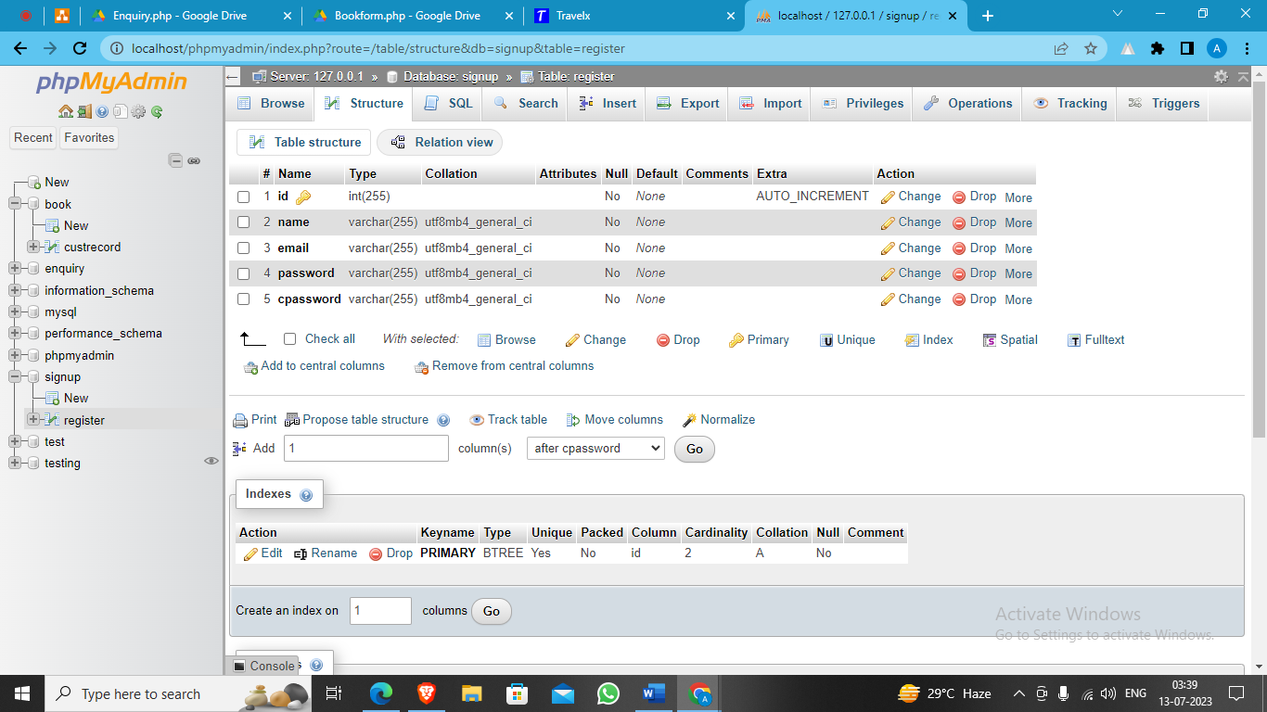

**Enquiry Form Database**

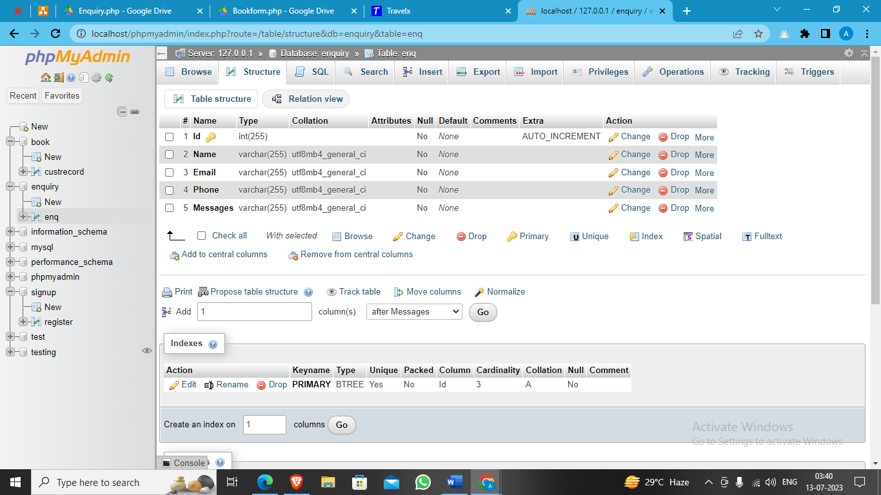

**Booking Form Database**



**Admin Database**

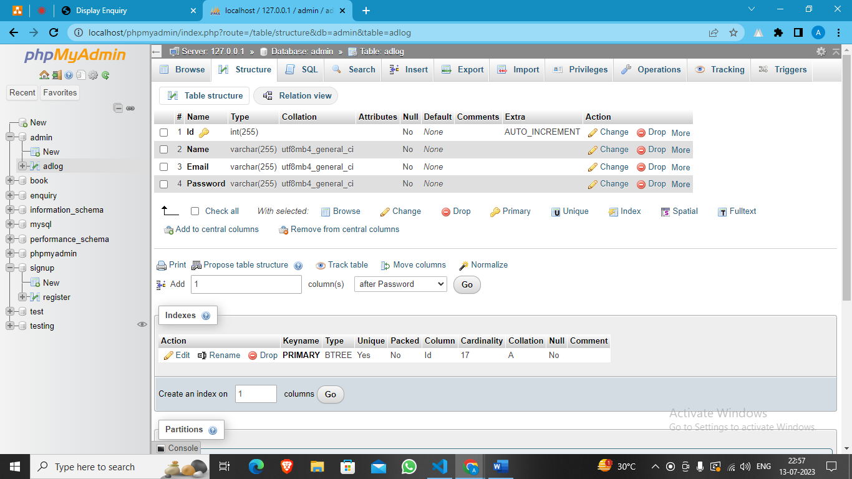

**User Interface Design**

**Sign Up Option**

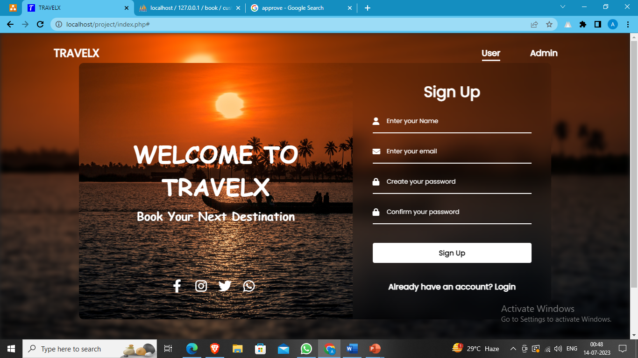

**Login Option**

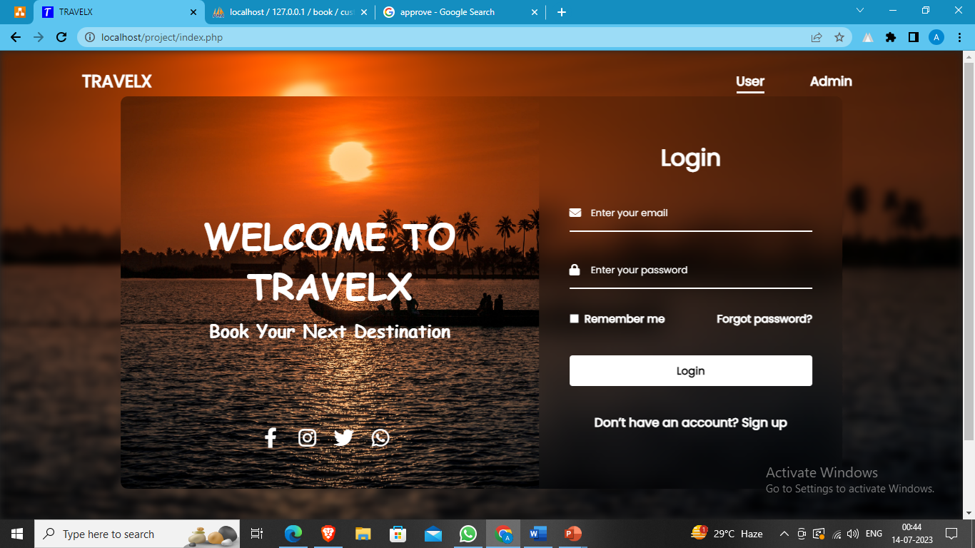

**Admin Login Page**

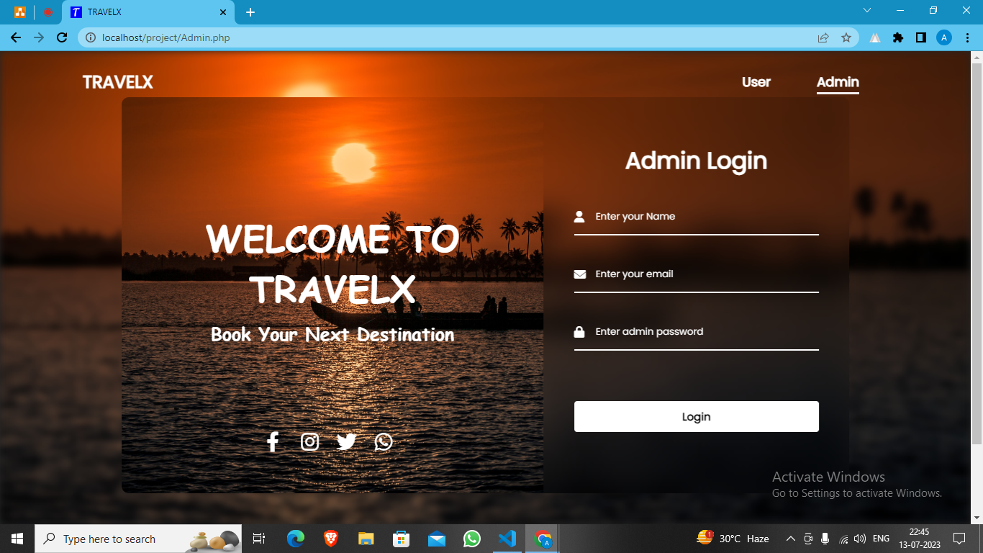

**Admin Home Page**

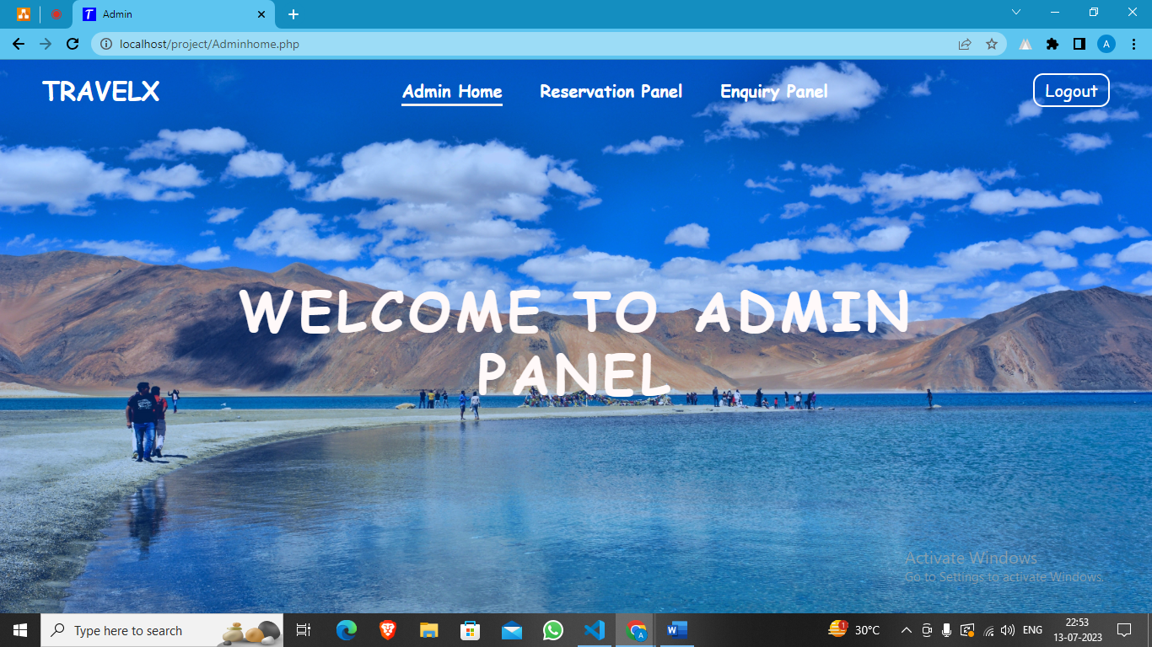

**Admin Reservation Panel**

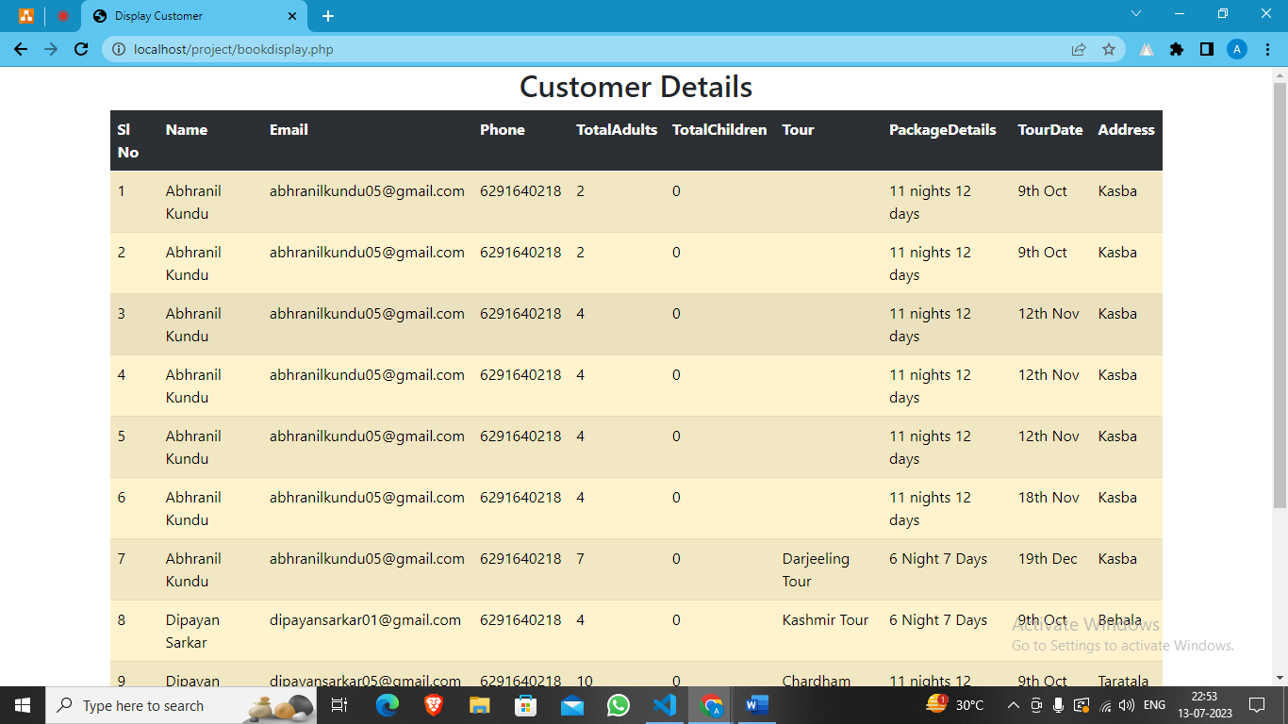

**Admin Enquiry Panel**

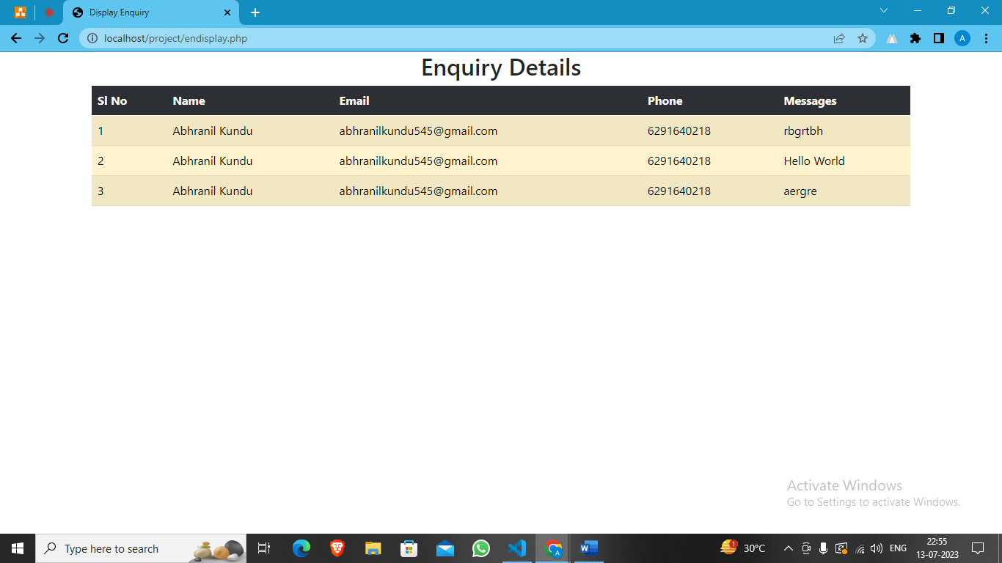

**User Home Page**

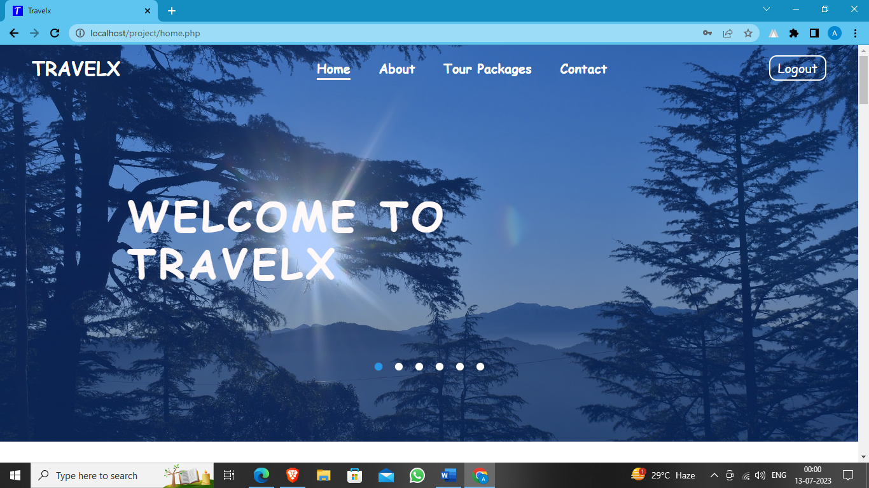

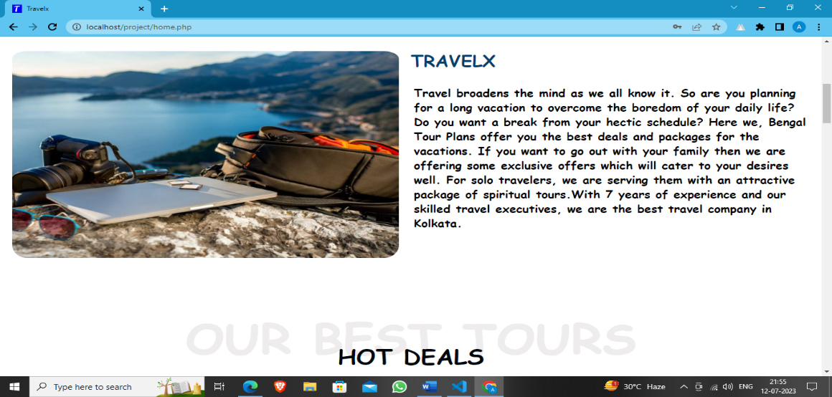

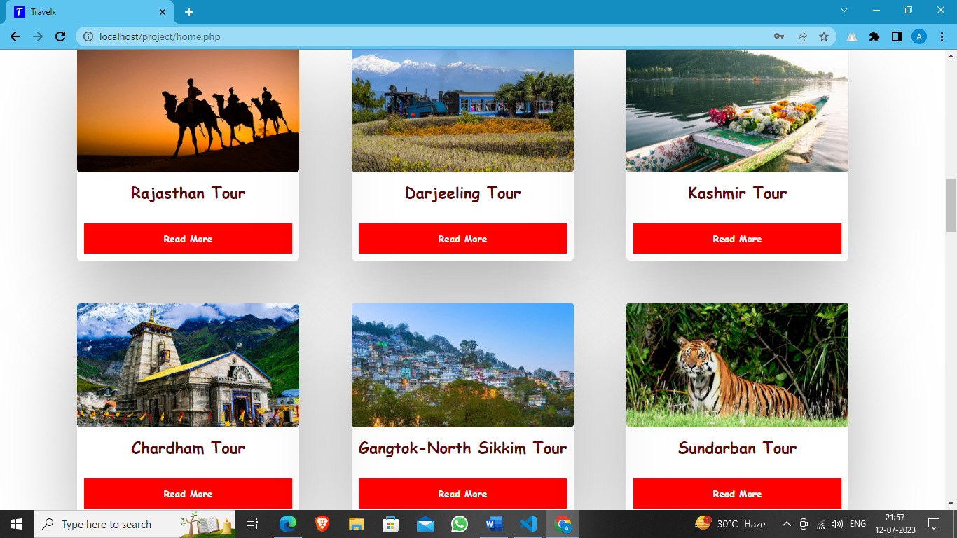

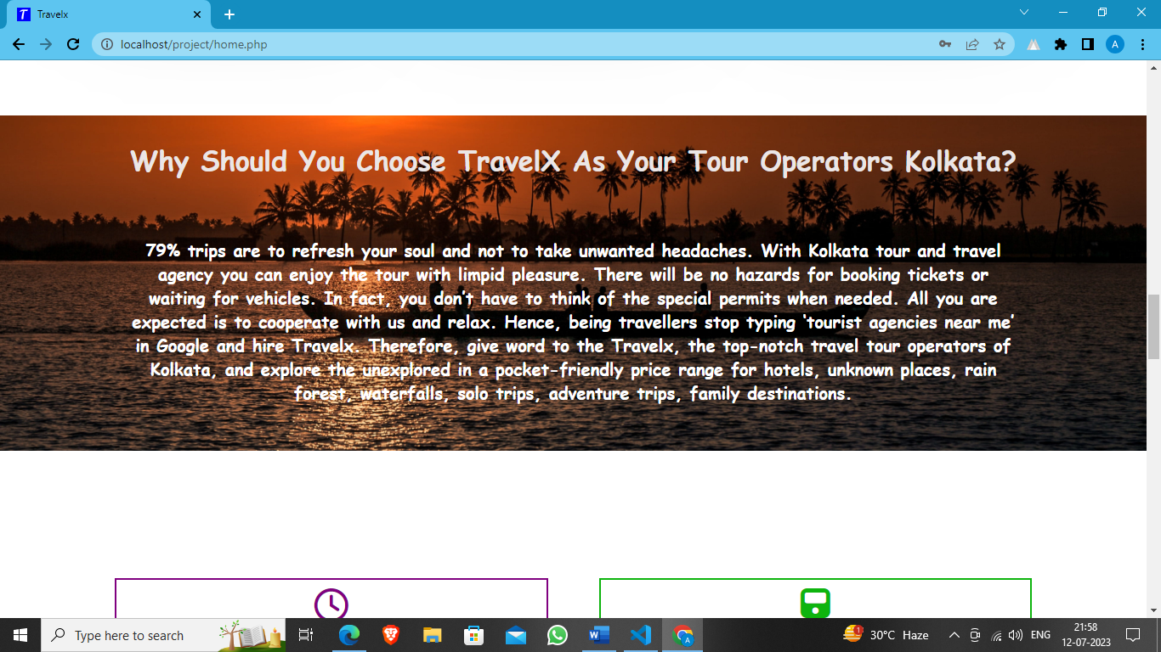

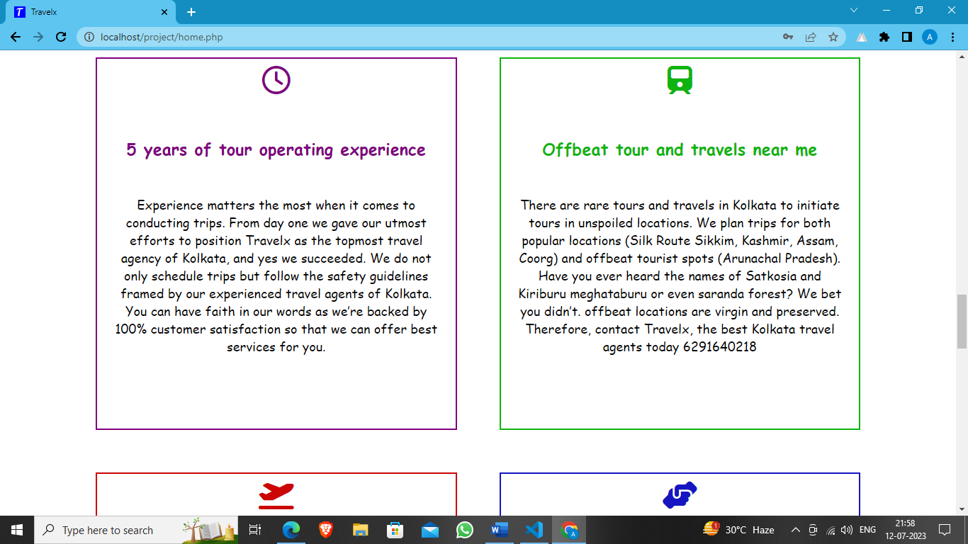

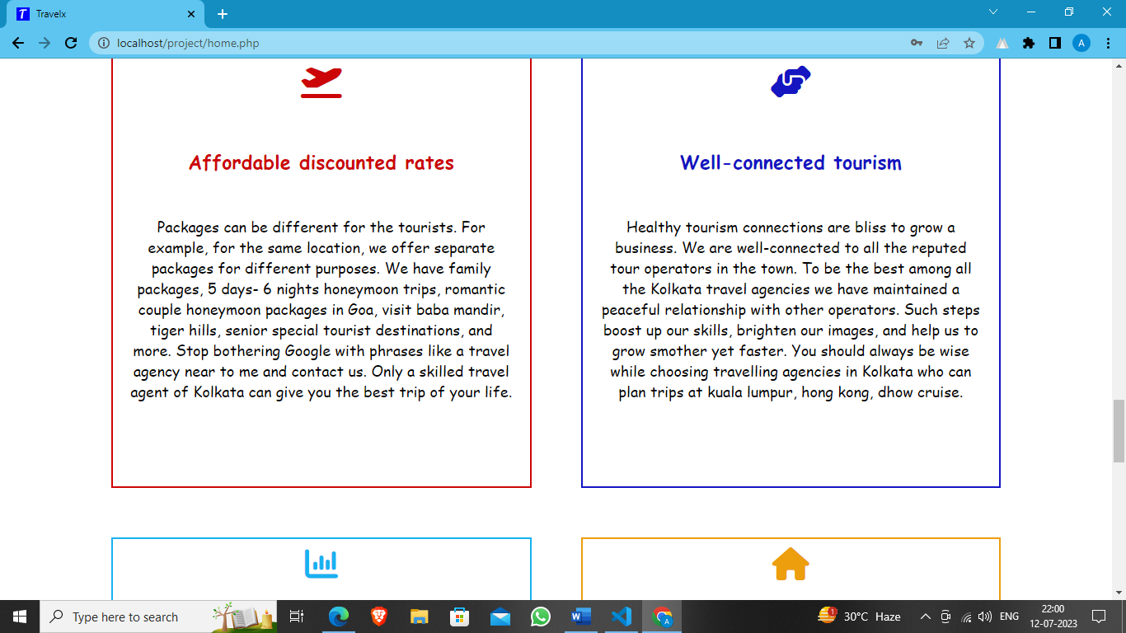

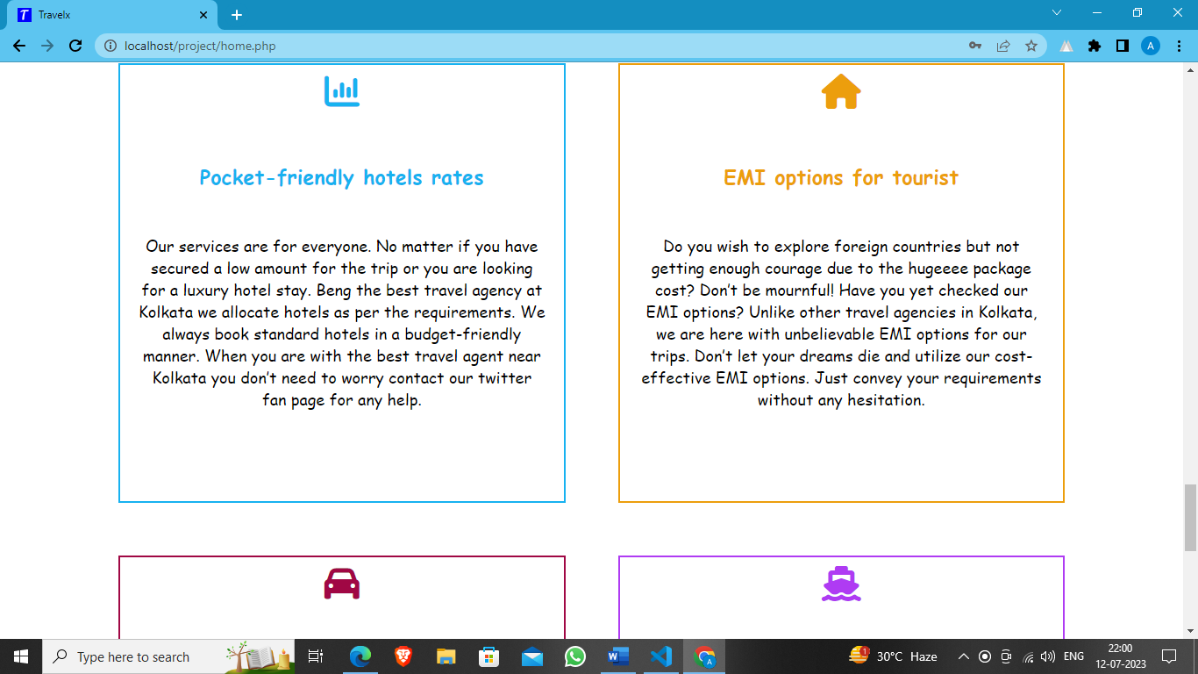

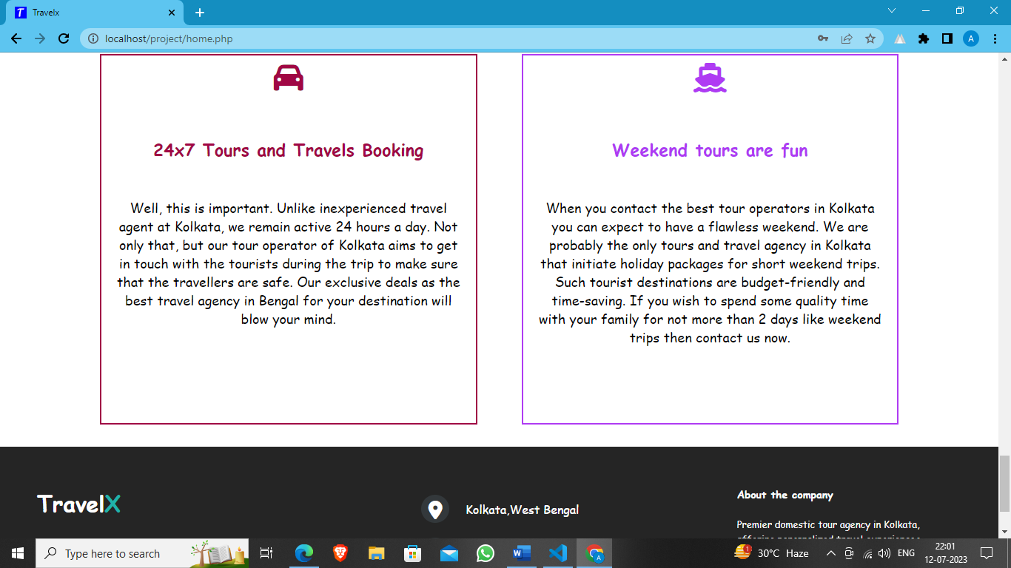

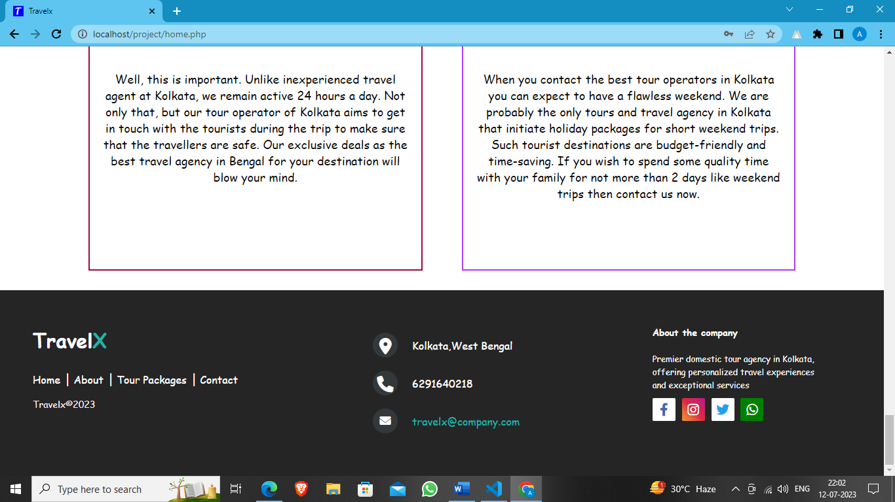

**About Page**

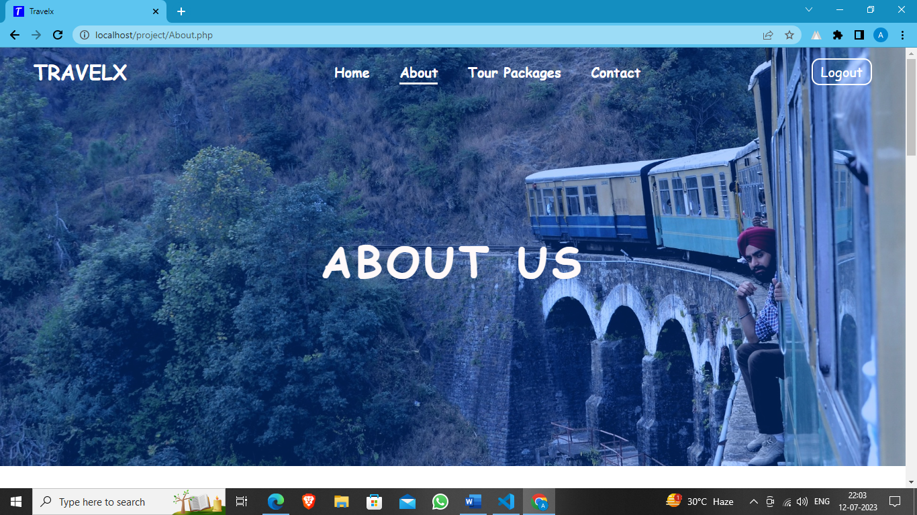

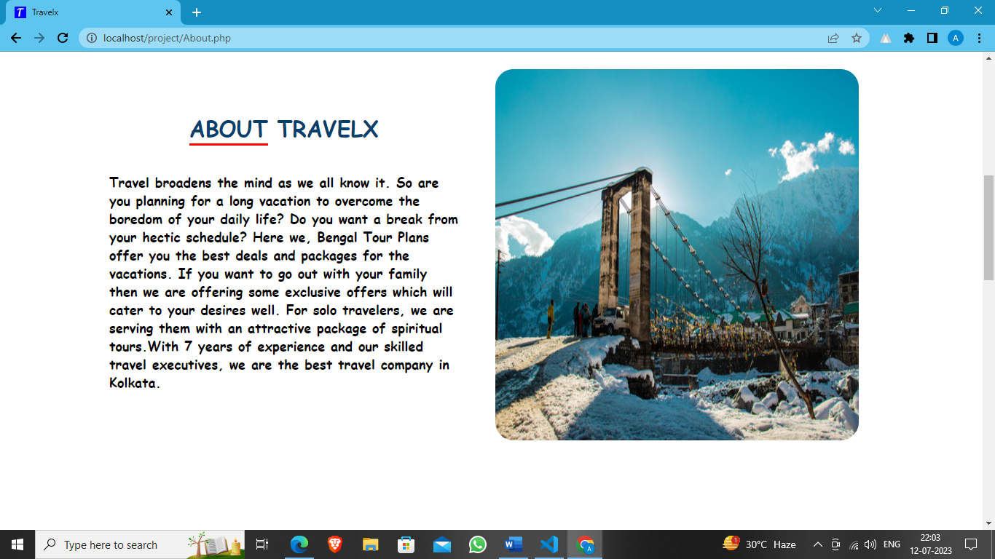

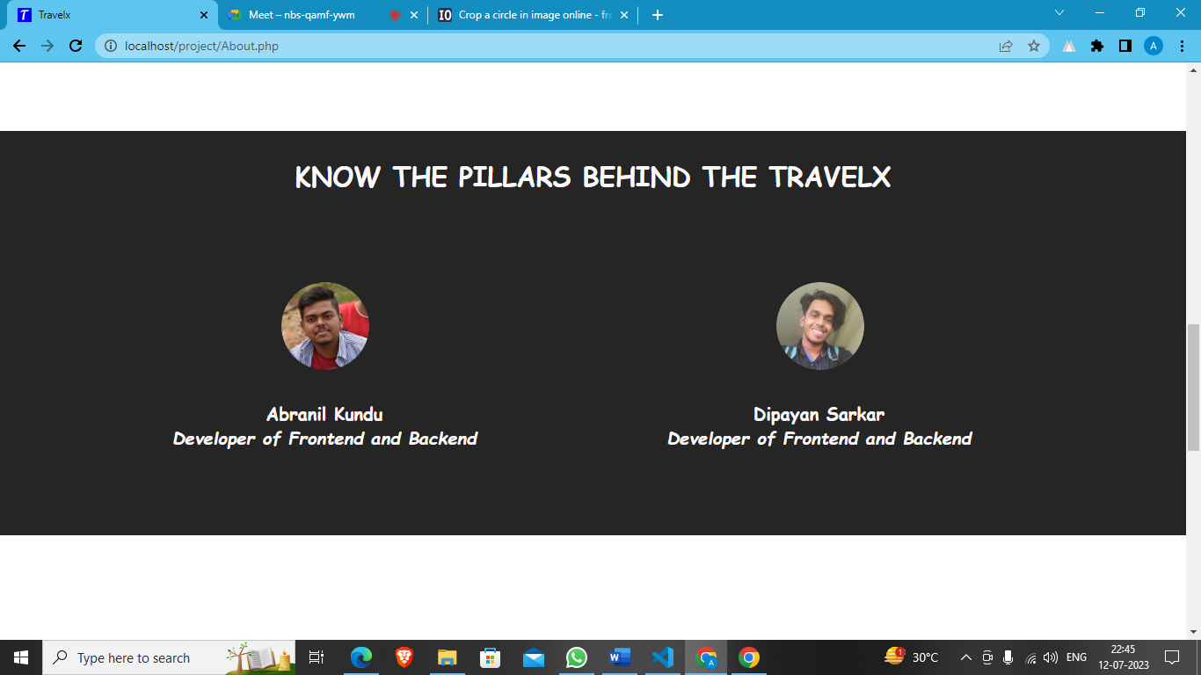

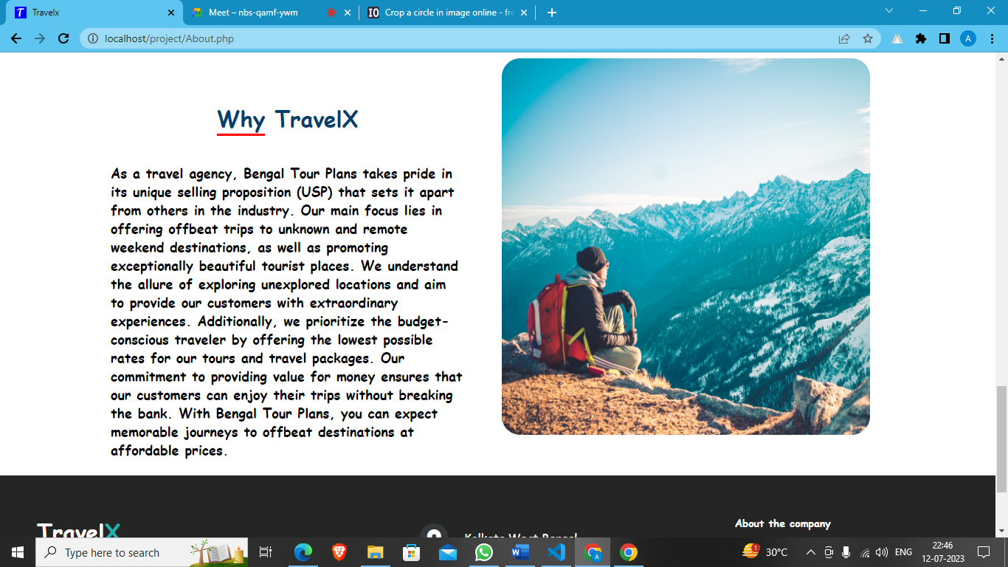

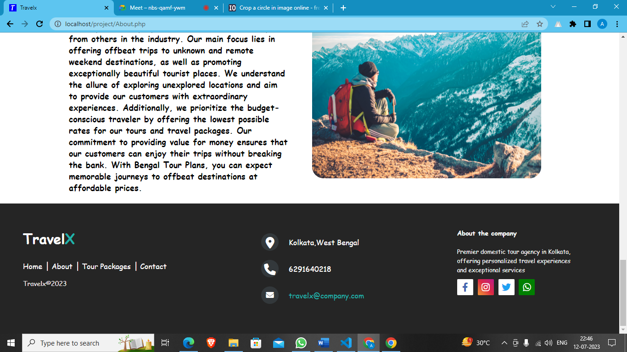

**Tour Packages Page**

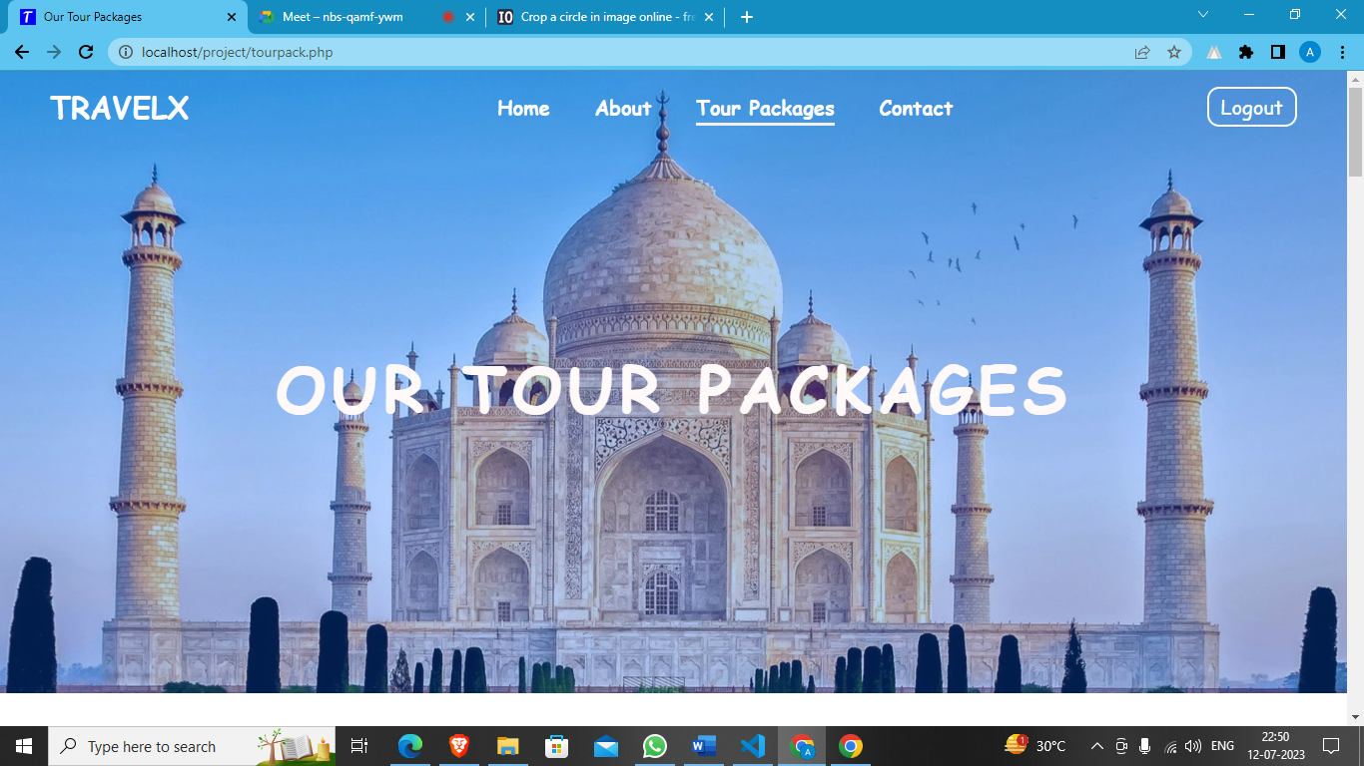



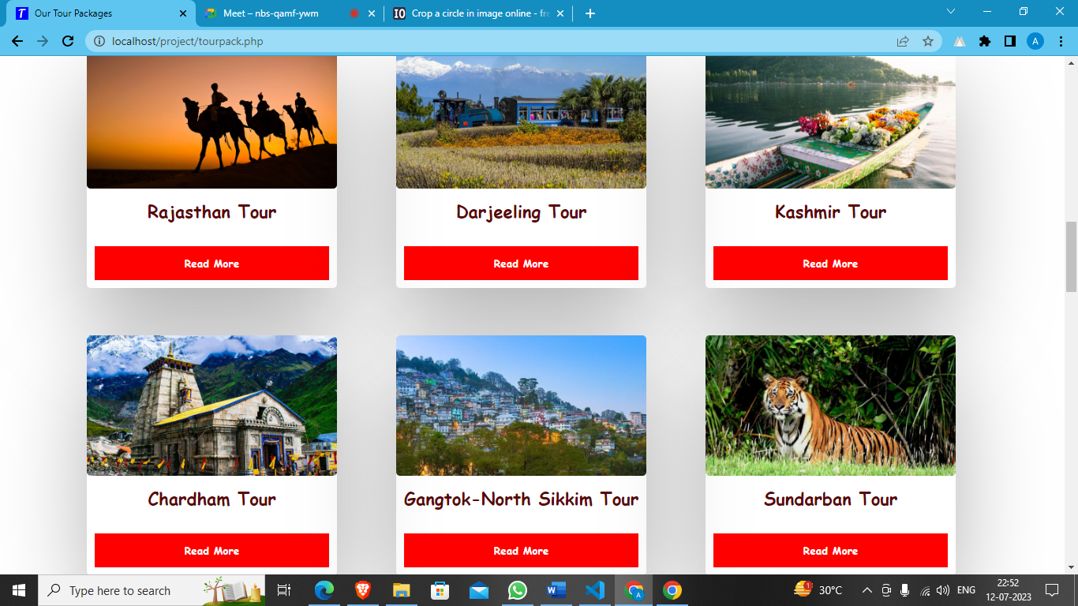

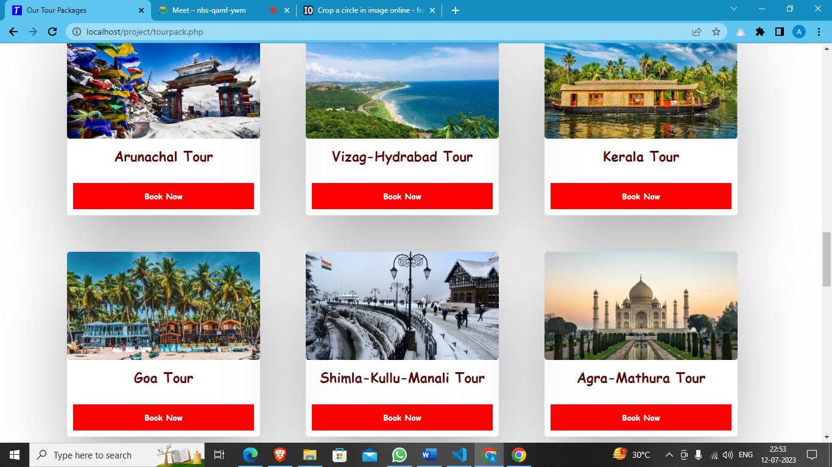

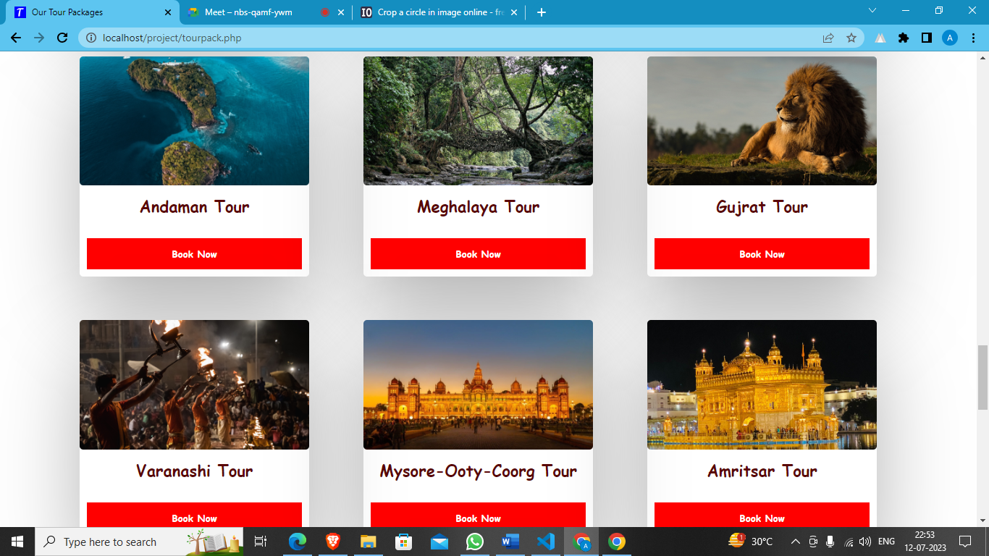

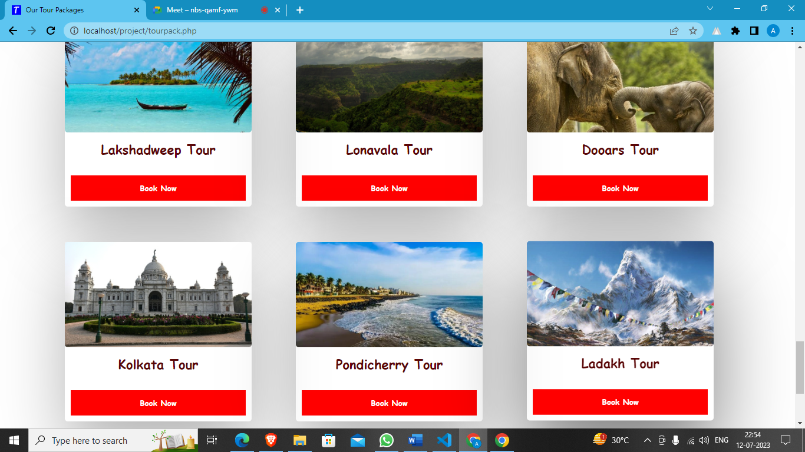

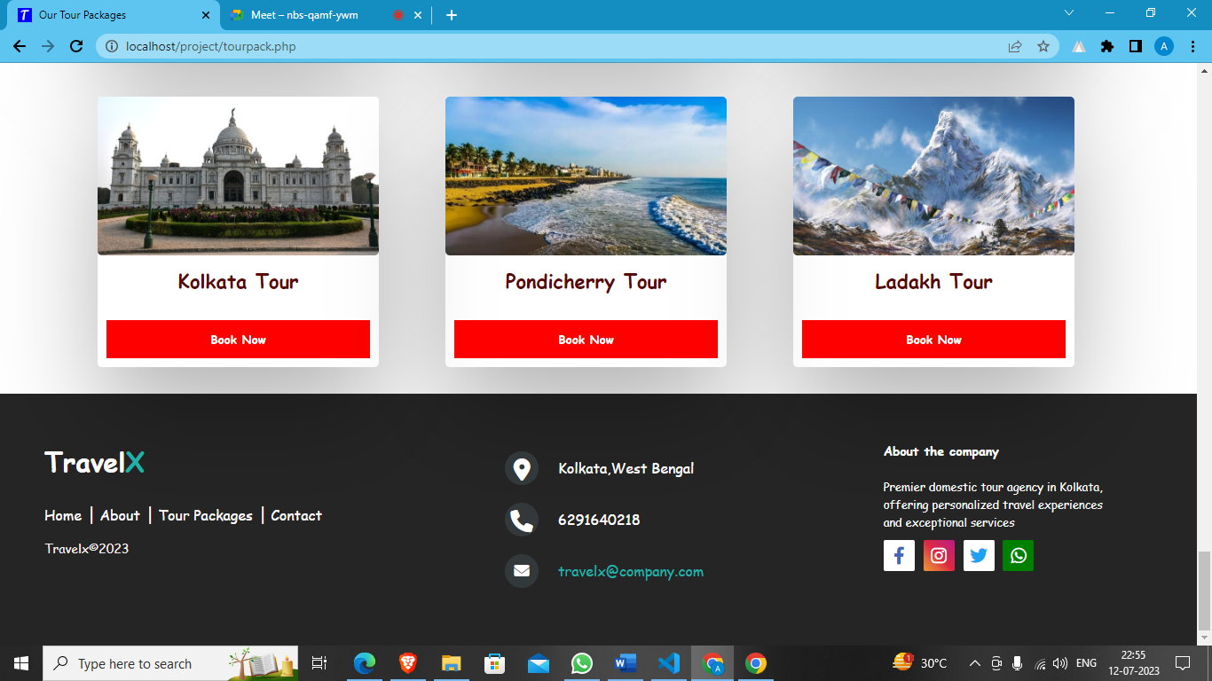

**Contact Page**

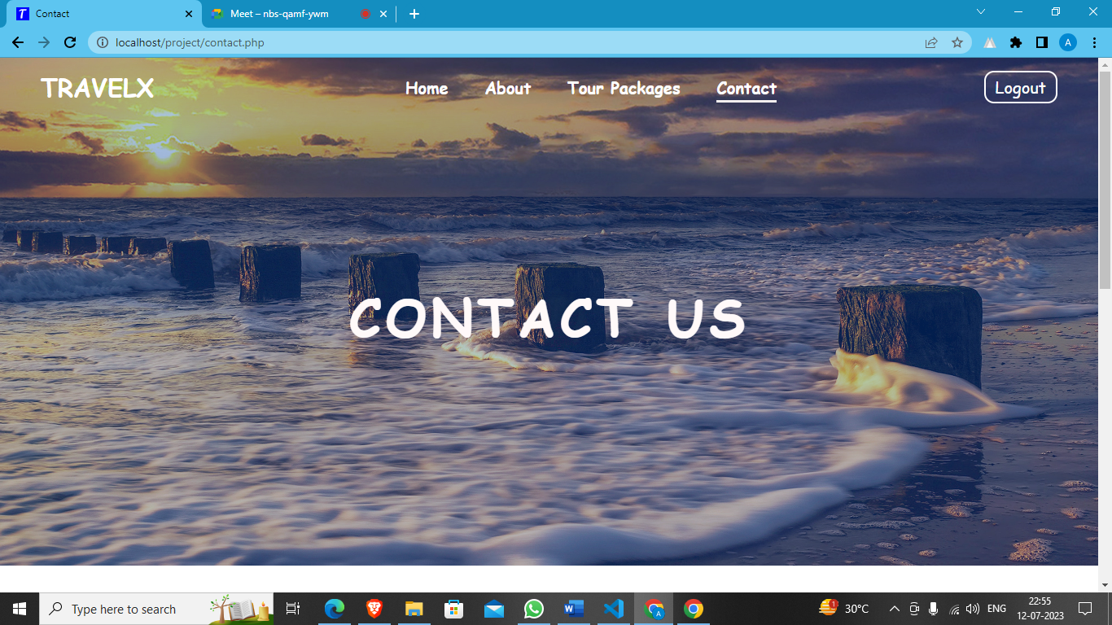

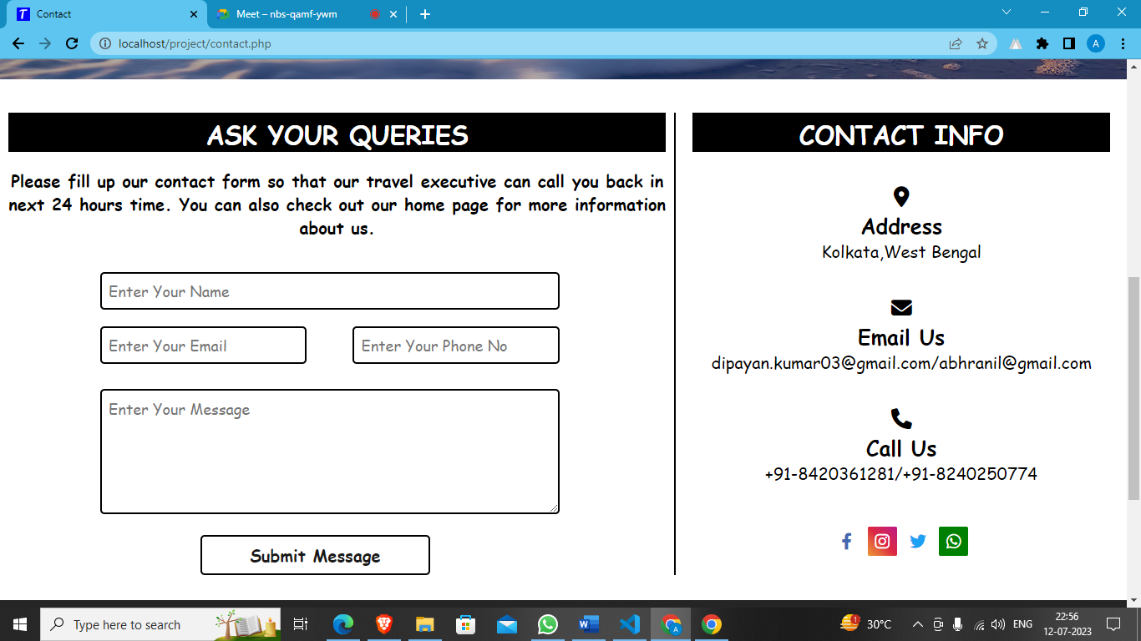

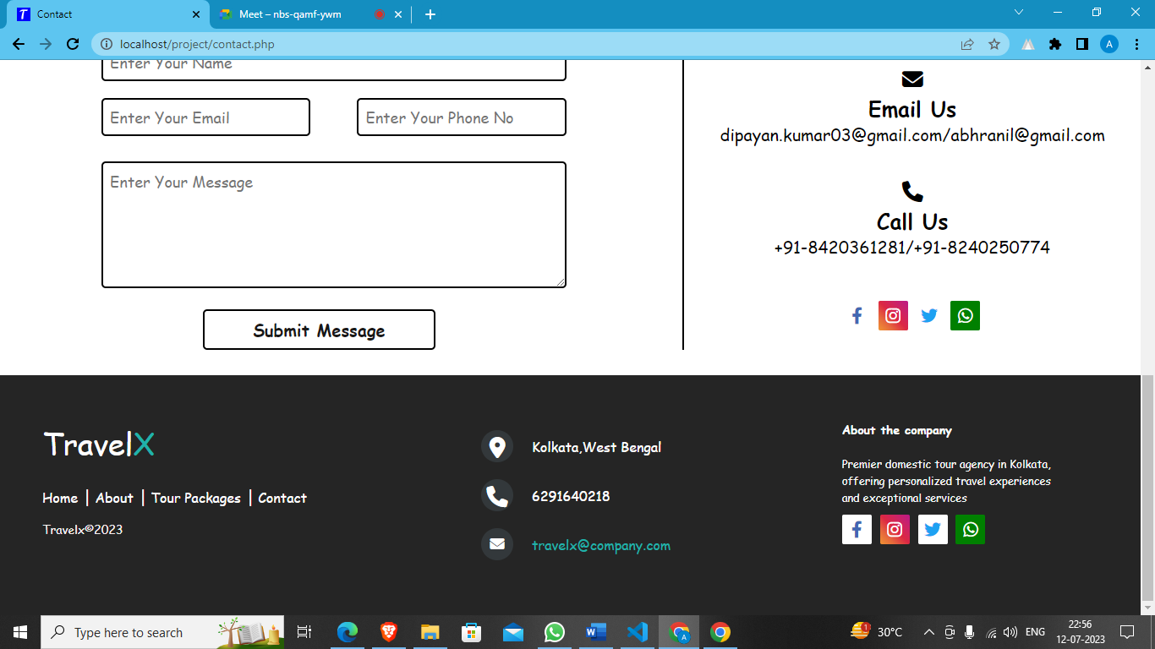

**Tour Page For Darjeeling**

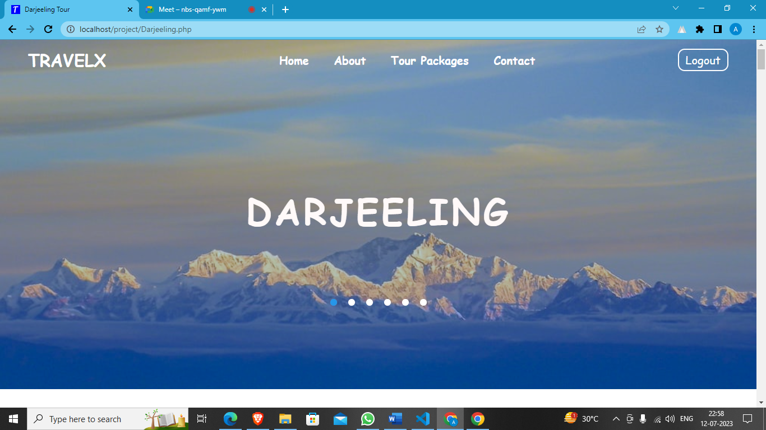

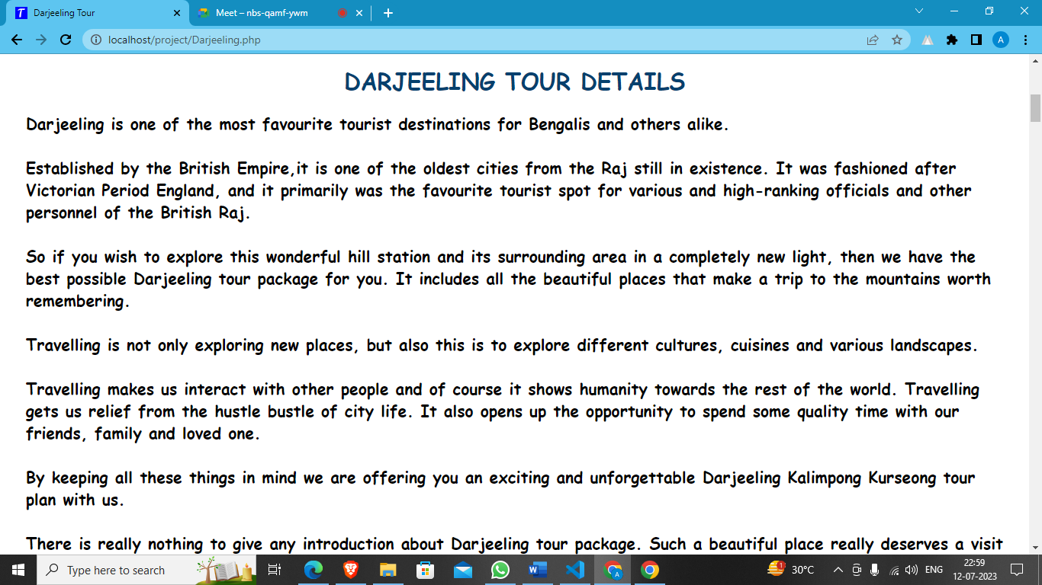

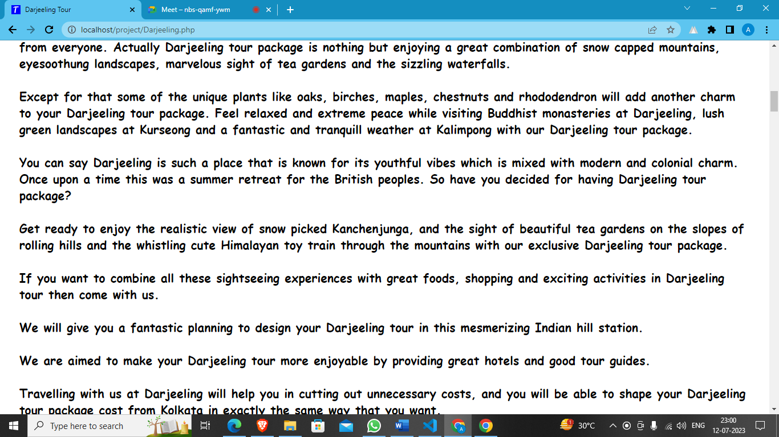

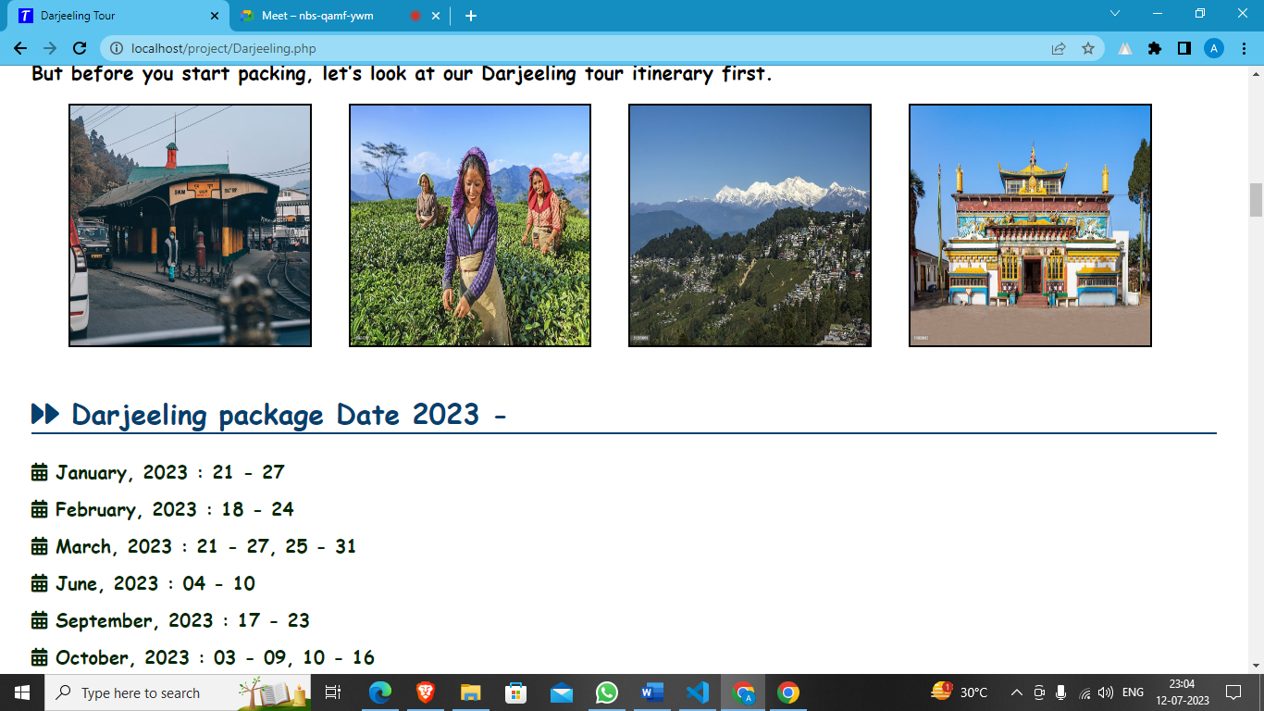

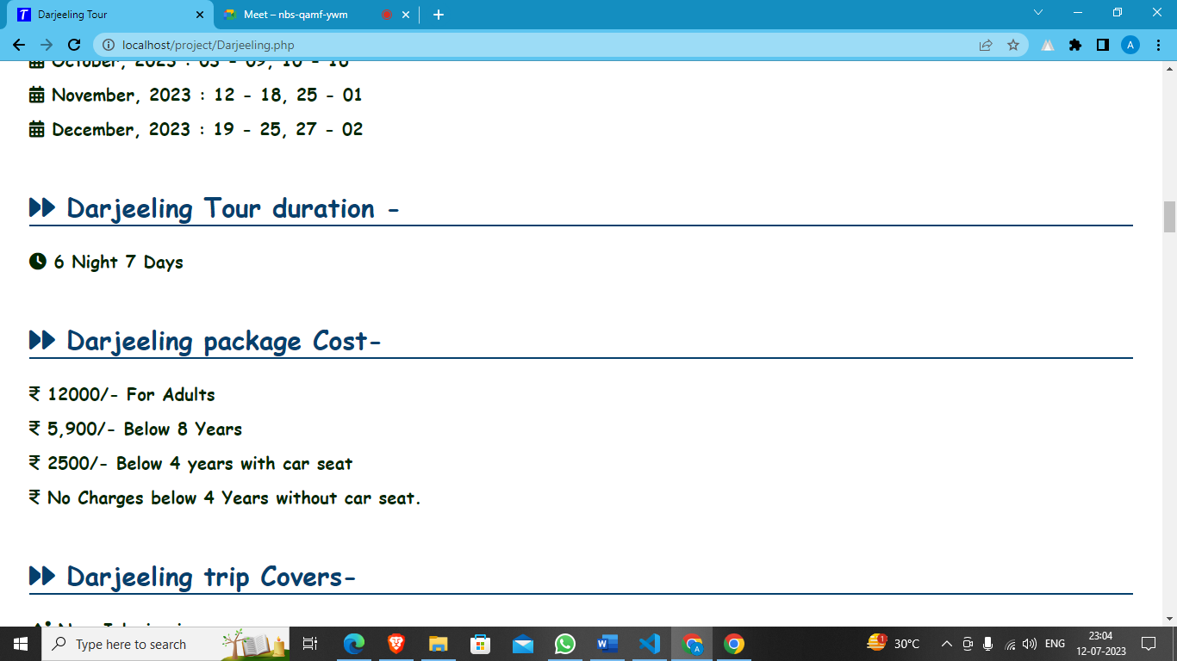

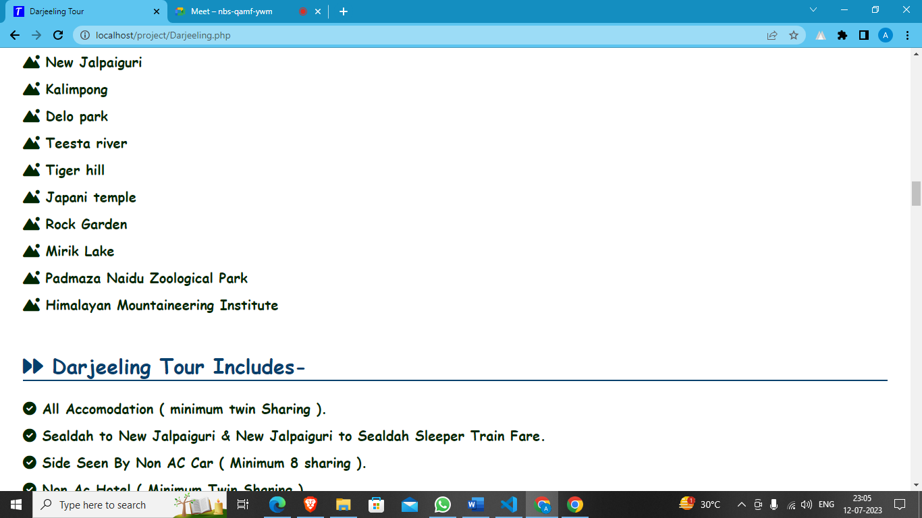

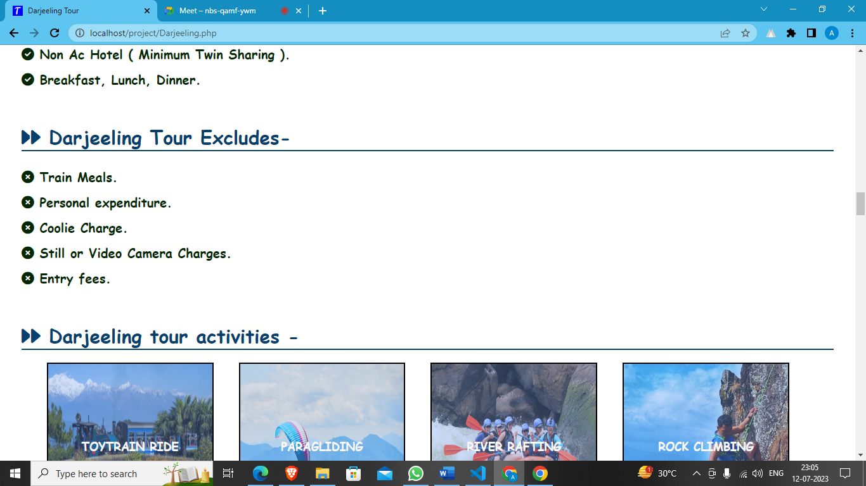

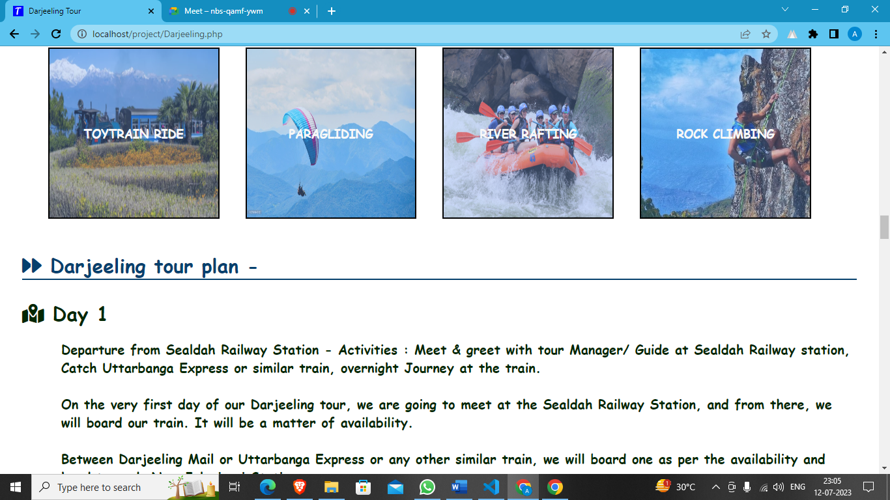

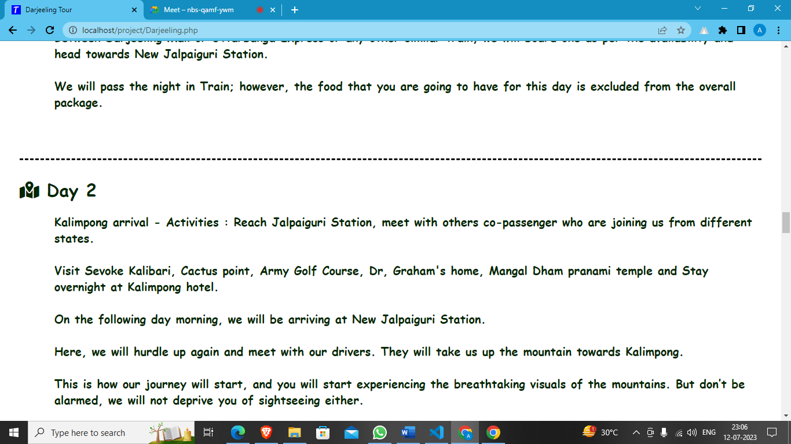

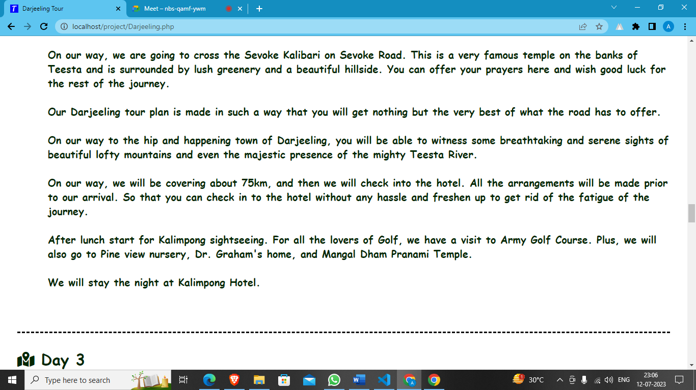

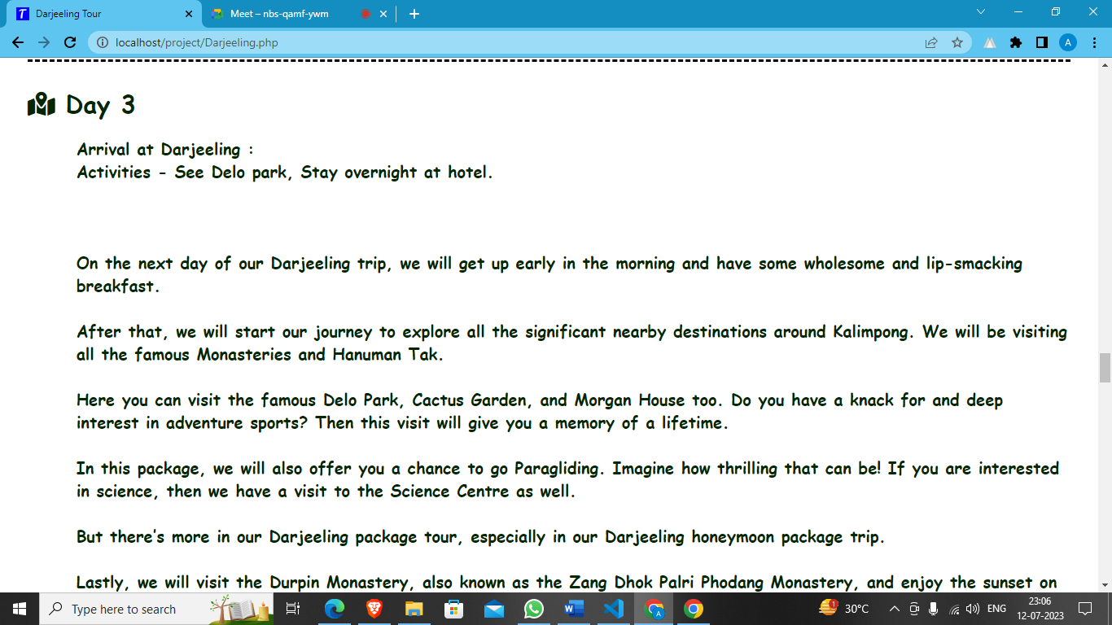

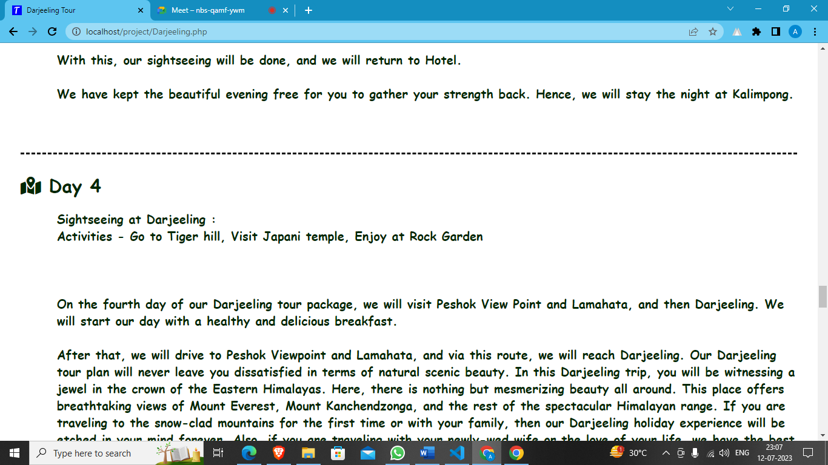

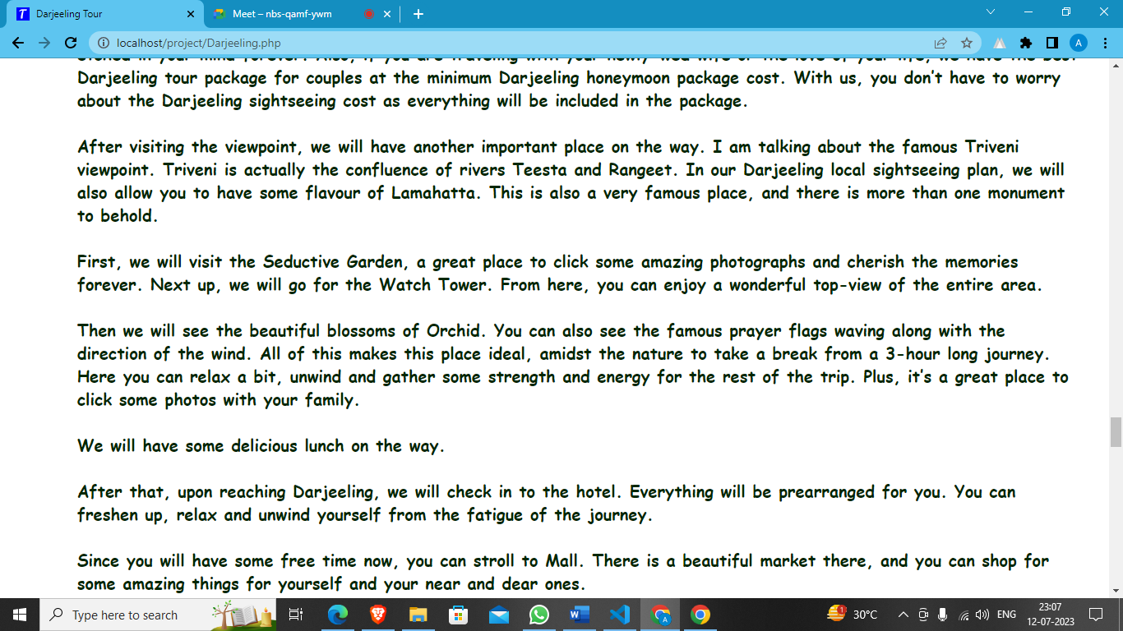

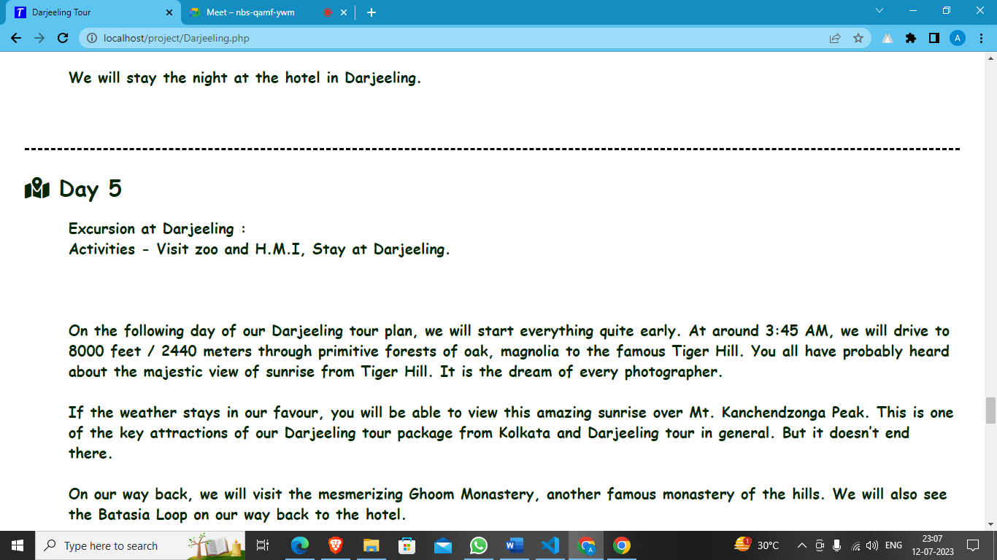

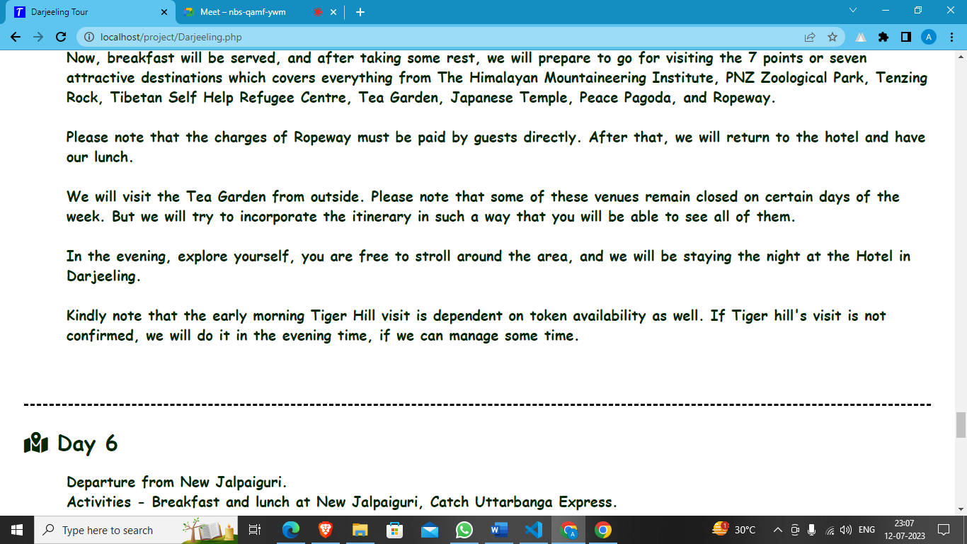

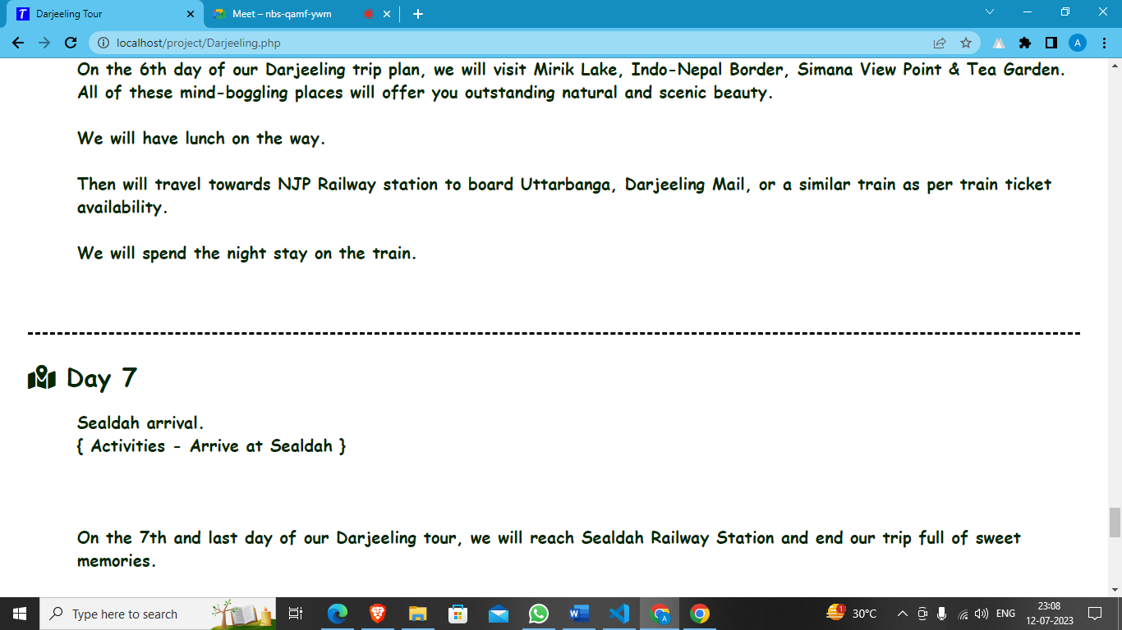

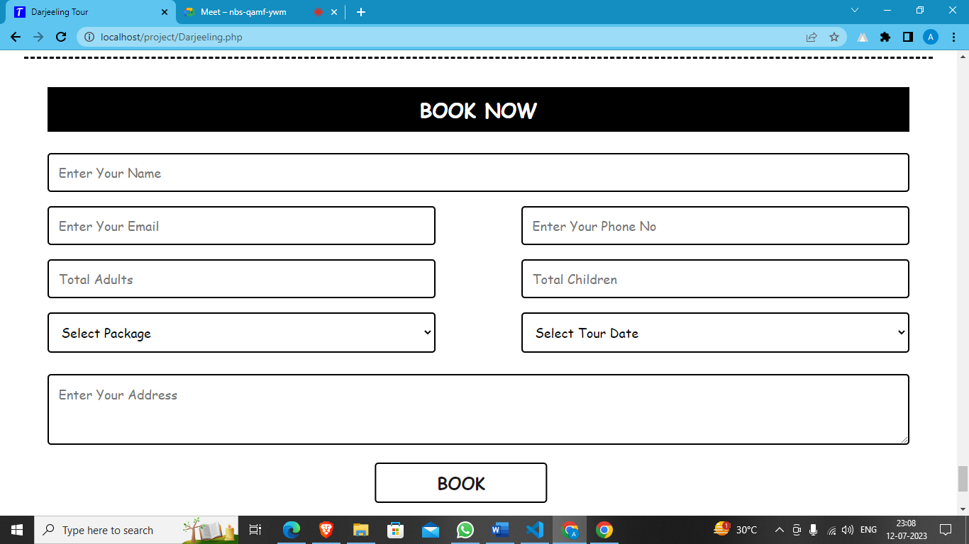

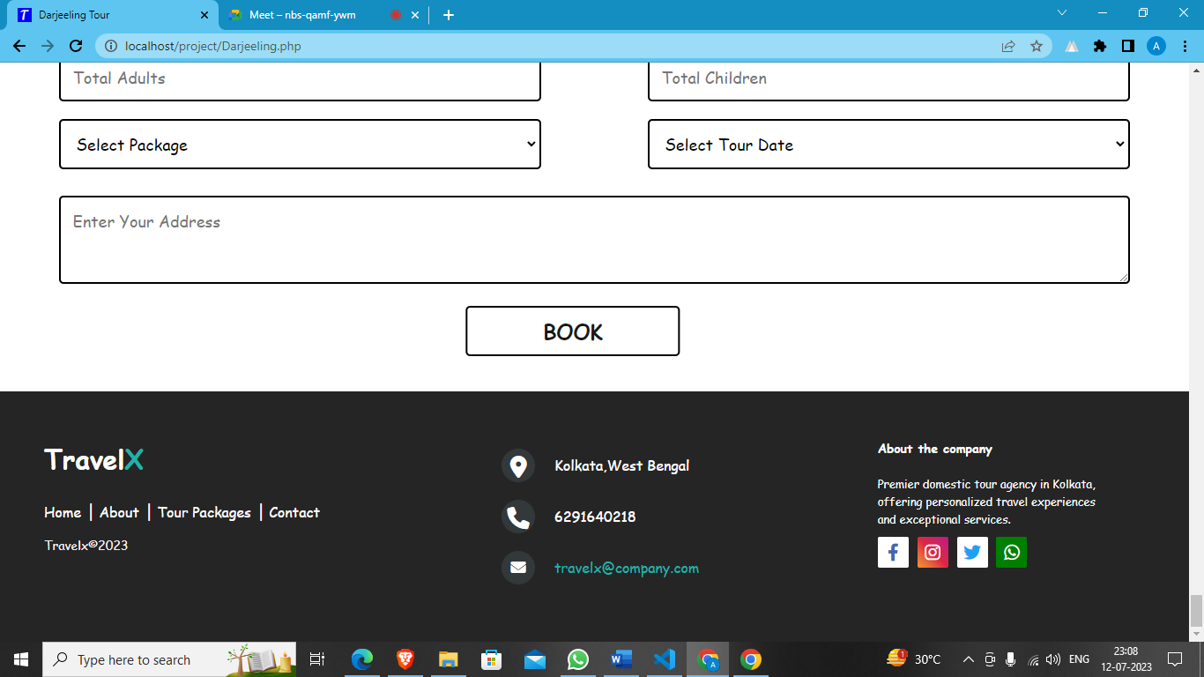

**Source Code**

<https://drive.google.com/drive/folders/1TgOr6nYFEZzmgSZ7I8ZnTyjaSCn1reT_?usp=sharing>

**Note: We provide the source code of our project.**

**Testing**

The following describes the level of team interaction necessary to have a successful product.

The Test Team will work closely with the Development Team to achieve a high quality design and user interface specifications based on customer requirements. The Test Team is responsible for visualizing test cases and raising quality issues and concerns during meetings to address issues early enough in the development cycle.

The Test Team will work closely with Development Team to determine whether or not the application meets standards for completeness. If an area is not acceptable for testing, the code complete date will be pushed out, giving the developers additional time to stabilize the area.

Since the application interacts with a back-end system component, the Test Team will need to include a plan for integration testing. Integration testing must be executed successfully prior to system testing.

**Test Objective**

The objective our test plan is to find and report as many bugs as possible to improve the integrity of our program. Although exhaustive testing is not possible, we will exercise a broad range of tests to achieve our goal. We will be testing a Binary Search Tree Application utilizing a pre-order traversal format.

There will be eight key functions used to manage our application: load, store, clear, search, insert, delete, list in ascending order, and list in descending order. Our user interface to utilize these functions is designed to be user-friendly and provide easy manipulation of the tree. The application will only be used as a demonstration tool, but we would like to ensure that it could be run from a variety of platforms with little impact on performance or usability.

**Process Overview:**

The following represents the overall flow of the testing process:

1. Identify the requirements to be tested. All test cases shall be derived using the current Program Specification.

2. Identify which particular test(s) will be used to test each module.

3. Review the test data and test cases to ensure that the unit has been thoroughly verified and that the test data and test cases are adequate to verify proper operation of the unit.

4. Identify the expected results for each test.

5. Document the test case configuration, test data, and expected results.

6. Perform the test(s).

7. Document the test data, test cases, and test configuration used during the testing process. This information shall be submitted via the Unit/System Test Report (STR).

8. Successful unit testing is required before the unit is eligible for component integration/system testing.

9. Unsuccessful testing requires a Bug Report Form to be generated. This document shall describe the test case, the problem encountered, its possible cause, and the sequence of events that led to the problem. It shall be used as a basis for later technical analysis.

10.Test documents and reports shall be submitted. Any specifications to be reviewed, revised, or updated shall be handled immediately.

**Testing Strategy**

The following outlines the types of testing that will be done for unit, integration, and system testing. While it includes what will be tested, the specific use cases that determine how the testing is done will be detailed in the Test Design Document. The test cases that will be used for designing use cases is shown in Figure 2.1 and onwards.

**Test Cases**

|  |  |
| --- | --- |
| Tested By | Dipayan Sarkar |
| Test Type | **Unit Testing** |
| Test Case Number | **5** |
| Test Case Name | **User Identification** |
| Test Case Description | **The user should enter his/ her accurate user id and password so that**  **he/she can able to go for the further options. The test case will check**  **the application for the same since a user can only login with the**  **correct user id, password** |
| Item(s) to be tested |  |
| 1 | **Verification of the user id and password with the record in the database.** |
| Specifications |  |
| Input | **Expected Output/Result** |
| Correct User id and password | **Successful login** |
| Incorrect Id or Password | **Failure Message** |

**Unit Testing:**

Unit Testing is done at the source or code level for language-specific programming errors such as bad syntax, logic errors, or to test particular functions or code modules. The unit test cases shall be designed to test the validity of the program’s correctness.

**White Box Testing:**

In white box testing, the UI is bypassed. Inputs and outputs are tested directly at the code level and the results are compared against specifications. This form of testing ignores the function of the program under test and will focus only on its

code and the structure of that code. Test case designers shall generate cases that not only cause each condition to take on all possible values at least once, but that cause each such condition to be executed at least once. To ensure this happens, we will be applying Branch Testing. Because the functionality of the program is relatively simple, this method will be feasible to apply.

Each function of the binary tree repository is executed independently; therefore, a program flow for each function has been derived from the code.

**Black Box Testing:**

Black box testing typically involves running through every possible input to verify that it results in the right outputs using the software as an end-user would. We have decided to perform Equivalence Partitioning and Boundary Value Analysis testing on our application.

**System Testing:**

The goals of system testing are to detect faults that can only be exposed by testing the entire integrated system or some major part of it. Generally, system testing is mainly concerned with areas such as performance, security, validation, load/stress, and configuration sensitivity. But in our case well focus only on function validation and performance. And in both cases we will use the black-box method of testing.

**System Security Measures:**

• Only authorized users are allowed.

• Without signing in users are not allowed to go an intermediate page by typing an URL. For all such efforts, users will be redirected to the home page.

**Database/Data Security:**

• Database is present in remote machine.

• MySQL’s default securities are applied.

**Cost Estimation of the Project along with Cost Estimation Model**

**Analogous estimate of effort or cost:**

Used for Early Estimate or Individual Activity Estimate.

Sample example shown below is for two major deliverables of a software project. You use a previous project as a benchmark for analogous estimation. Using your experience you will estimate a multiplier.

**Multipliers:**

1. Prototyping: 0.75.

2. Testing: 0.5

3. Deployment: 0.5

**Finally, if you want to convert to cost, you would use current rates for the resource.**

|  |  |  |  |  |  |  |
| --- | --- | --- | --- | --- | --- | --- |
| WBS ID | Previous Similar Project Activity | Previous Effort | Current Project Estimate | Multiplier | Effort (Previous Effort * 0.75) | Cost(Rs. 500/hr.) |
| 1 | Prototyping | 40 Work-Hours | Prototyping | 0.75 | 30 Work-hours | Rs. 15000/- |
| 2 | Testing | 20 Work-Hours | Testing | 0.50 | 10 Work-Hours | Rs. 5000/- |
| Total |  |  |  |  | 40 Work-Hour | 40 Work-Hour |

Note: Effort is also called Size and unit of estimation is called either Work-Hour, person-hours.

**Future scope and further enhancement of the Project**

• Social Network Integration

• Online Payment Integration

**Conclusion**

In conclusion, tour and travel websites have revolutionized the way people plan and book their trips. These platforms provide a convenient and user-friendly interface for travellers to research destinations, compare prices, and make reservations. With a wide range of features and resources available, they empower individuals to have more control and autonomy over their travel arrangements. Additionally, tour and travel websites benefit the industry by serving as a virtual marketplace for service providers to reach a larger audience. Overall, these websites are indispensable tools for travellers, simplifying the journey from inspiration to realization.

**Bibliography**

[**https://www.w3schools.com/**](https://www.w3schools.com/)

[**https://www.javatpoint.com/**](https://www.javatpoint.com/)

[**https://www.geeksforgeeks.org/**](https://www.geeksforgeeks.org/)

[**https://www.canva.com/\**](https://www.canva.com/\)

**--------------------------END------------------------**